# Analyzing Business Success Impact Factors With Yelp & Crime Data

Xiancheng Yin, Khawlah Basulayb

**Describe the topic:**

The project will explore various aspects of business performance and customer satisfaction in Philadelphia using the Yelp dataset and Philadelphia Crime Data.

It aims to analyze: (1) how the time of day, day of the week, and cuisine type impact customer check-ins, (2) which cuisine types experience the highest check-ins during different times of the day, (3) the impact of crime on businesses in Philadelphia, (4) the relationship between customer review sentiment, Yelp user attributes, and business performance, and (5) how public safety concerns in certain areas of Philadelphia influence business types, customer behaviors, check-in times, and reviews.

This analysis will provide valuable insights into factors shaping customer preferences, business success, and the interplay between safety and commerce within the city.

# 

# **Data Set**

# 

# 

# https://www.kaggle.com/datasets/yelp-dataset/yelp-dataset?select=yelp_academic_dataset_business.json

https://www.kaggle.com/datasets/mchirico/philadelphiacrimedata

# 

# 

# **Design**

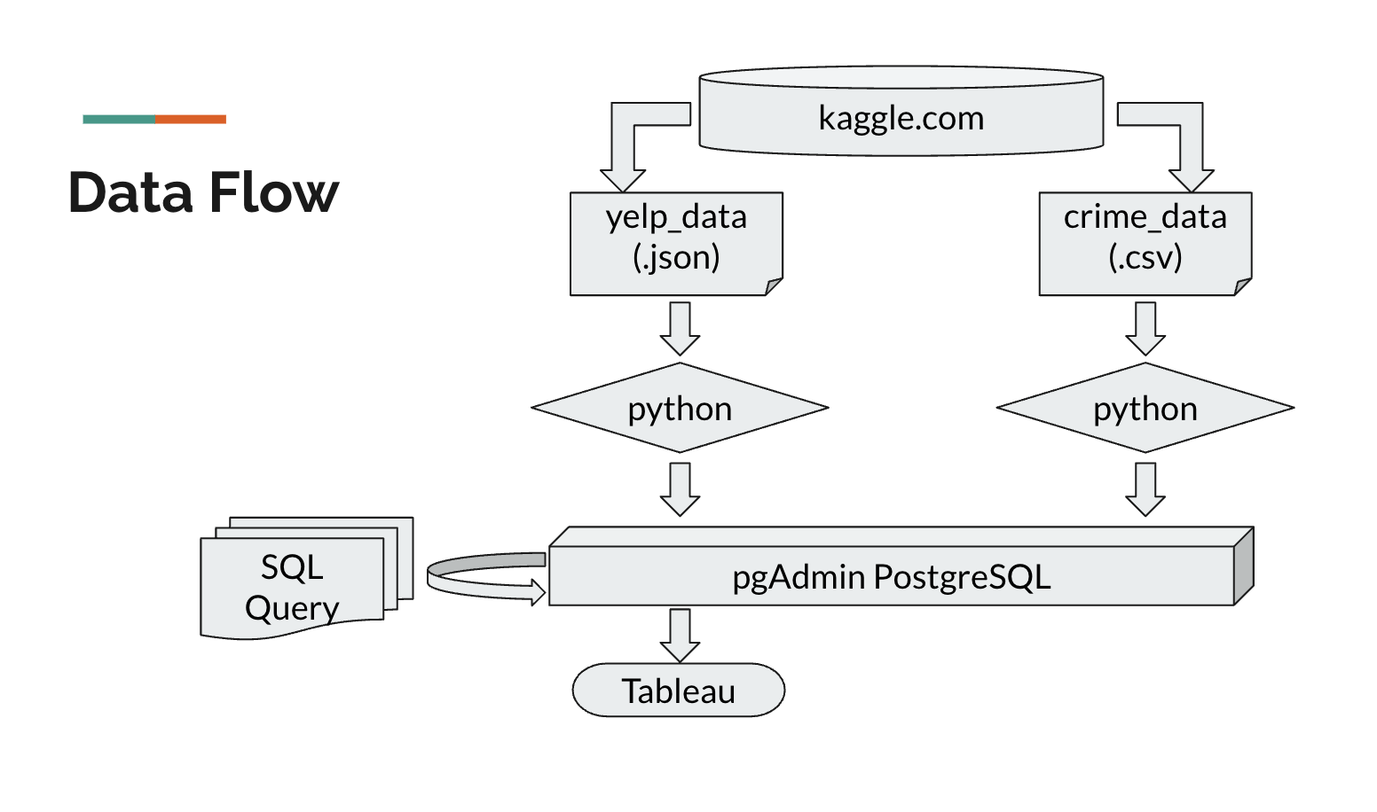

**ERD**

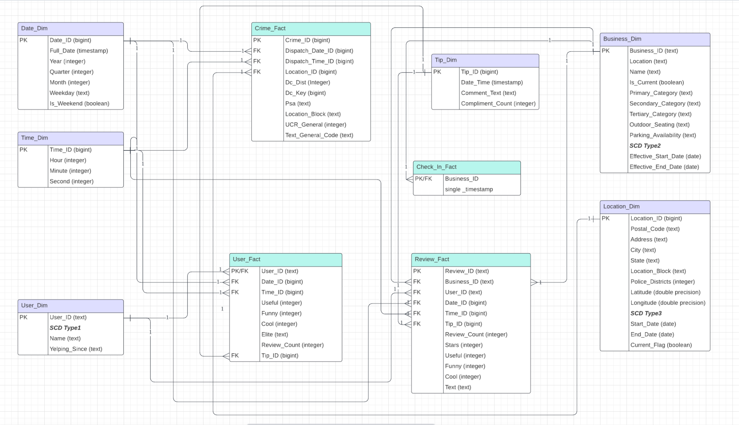

**The grain of each fact table defines the level of details:**

### Crime_Fact

Grain: Each row represents a single crime event.

**Attributes:**

* + Crime_ID: Unique identifier for each crime event.
  + Dispatch_Date_ID, Dispatch_Time_ID: Link to date and time dimensions for the dispatch.
  + Location_ID: Link to the location where the crime occurred.
  + Other fields (e.g., Dc_Dist, UCR_General, etc.) provide details about the crime.

### 2. Check_In_Fact

Grain: Each row represents a single check-in event at a specific business at a specific timestamp.

**Attributes:**

* + Business_ID: Identifies the business where the check-in occurred.
  + single_timestamp: The exact time of the check-in.

### 3. User_Fact

Grain: Each row represents user activity or behavior during a specific time period.

**Attributes:**

* + User_ID: Identifies the user.
  + Date_ID and Time_ID: Link to date and time dimensions for when the activity occurred.
  + Additional columns like Useful, Funny, Cool track user contributions or ratings.

### 4. Review_Fact

Grain: Each row represents a single review given by a user for a specific business at a specific time.

**Attributes:**

* + Review_ID: Unique identifier for the review.
  + Business_ID: The business being reviewed.
  + User_ID: The user writing the review.
  + Date_ID, Time_ID: Link to date and time dimensions for when the review was made.
  + Additional columns like Stars, Useful, Text provide details about the review content.

### 

### 5. Tip_Dim

Grain: Each row represents a single tip provided for a business.

**Attributes:**

* + Tip_ID: Unique identifier for the tip.
  + Date_Time: Timestamp of when the tip was created.
  + Comment_Text: The actual tip content.
  + Compliment_Count: Number of compliments received for the tip.

### 6. Business_Dim

Grain: Each row represents a single business, with attributes like location, category, and availability.

### 7. Location_Dim

Grain: Each row represents a single location, identified by Location_ID.

### 8. Date_Dim and Time_Dim

Grain:

* + Date_Dim: Each row represents a single calendar date.
  + Time_Dim: Each row represents a specific time of day (hour, minute, second).

**Business Questions:**

**1. How does the time of day, day of week and cuisine type, impact customer check-ins ?**

**2. Which cuisine types have the highest check-ins during different times of the day?**

**3. What is the impact of crime on business if there is(Philadelphia Crime Data) ?**

**4. What is the relationship between number of reviews, reaction to review and number of tips?**

**5. How public safety concerns in the area of Philadelphia affect business types and customer behaviors( check-in time and reviews)**

# 

# **ETL**

In the Data Set section, we have shown how the data was extracted from the data source.

So we move on to Transform and Load.

Load Business_Dim

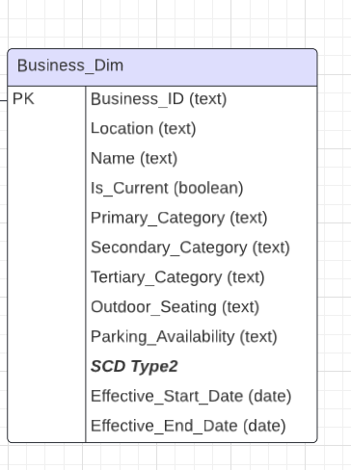

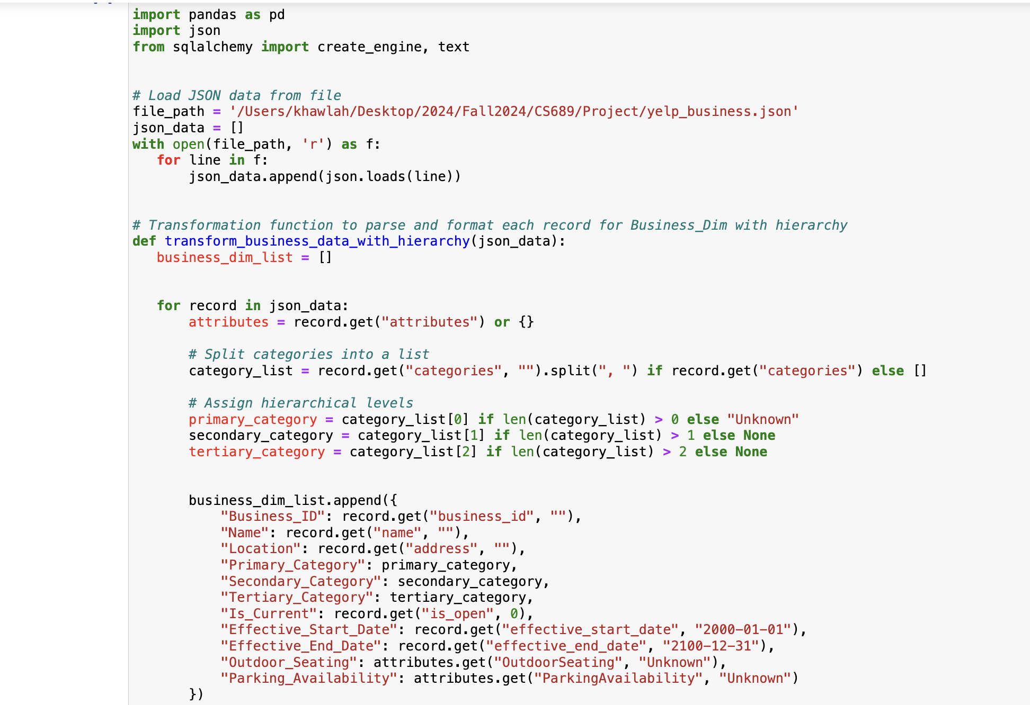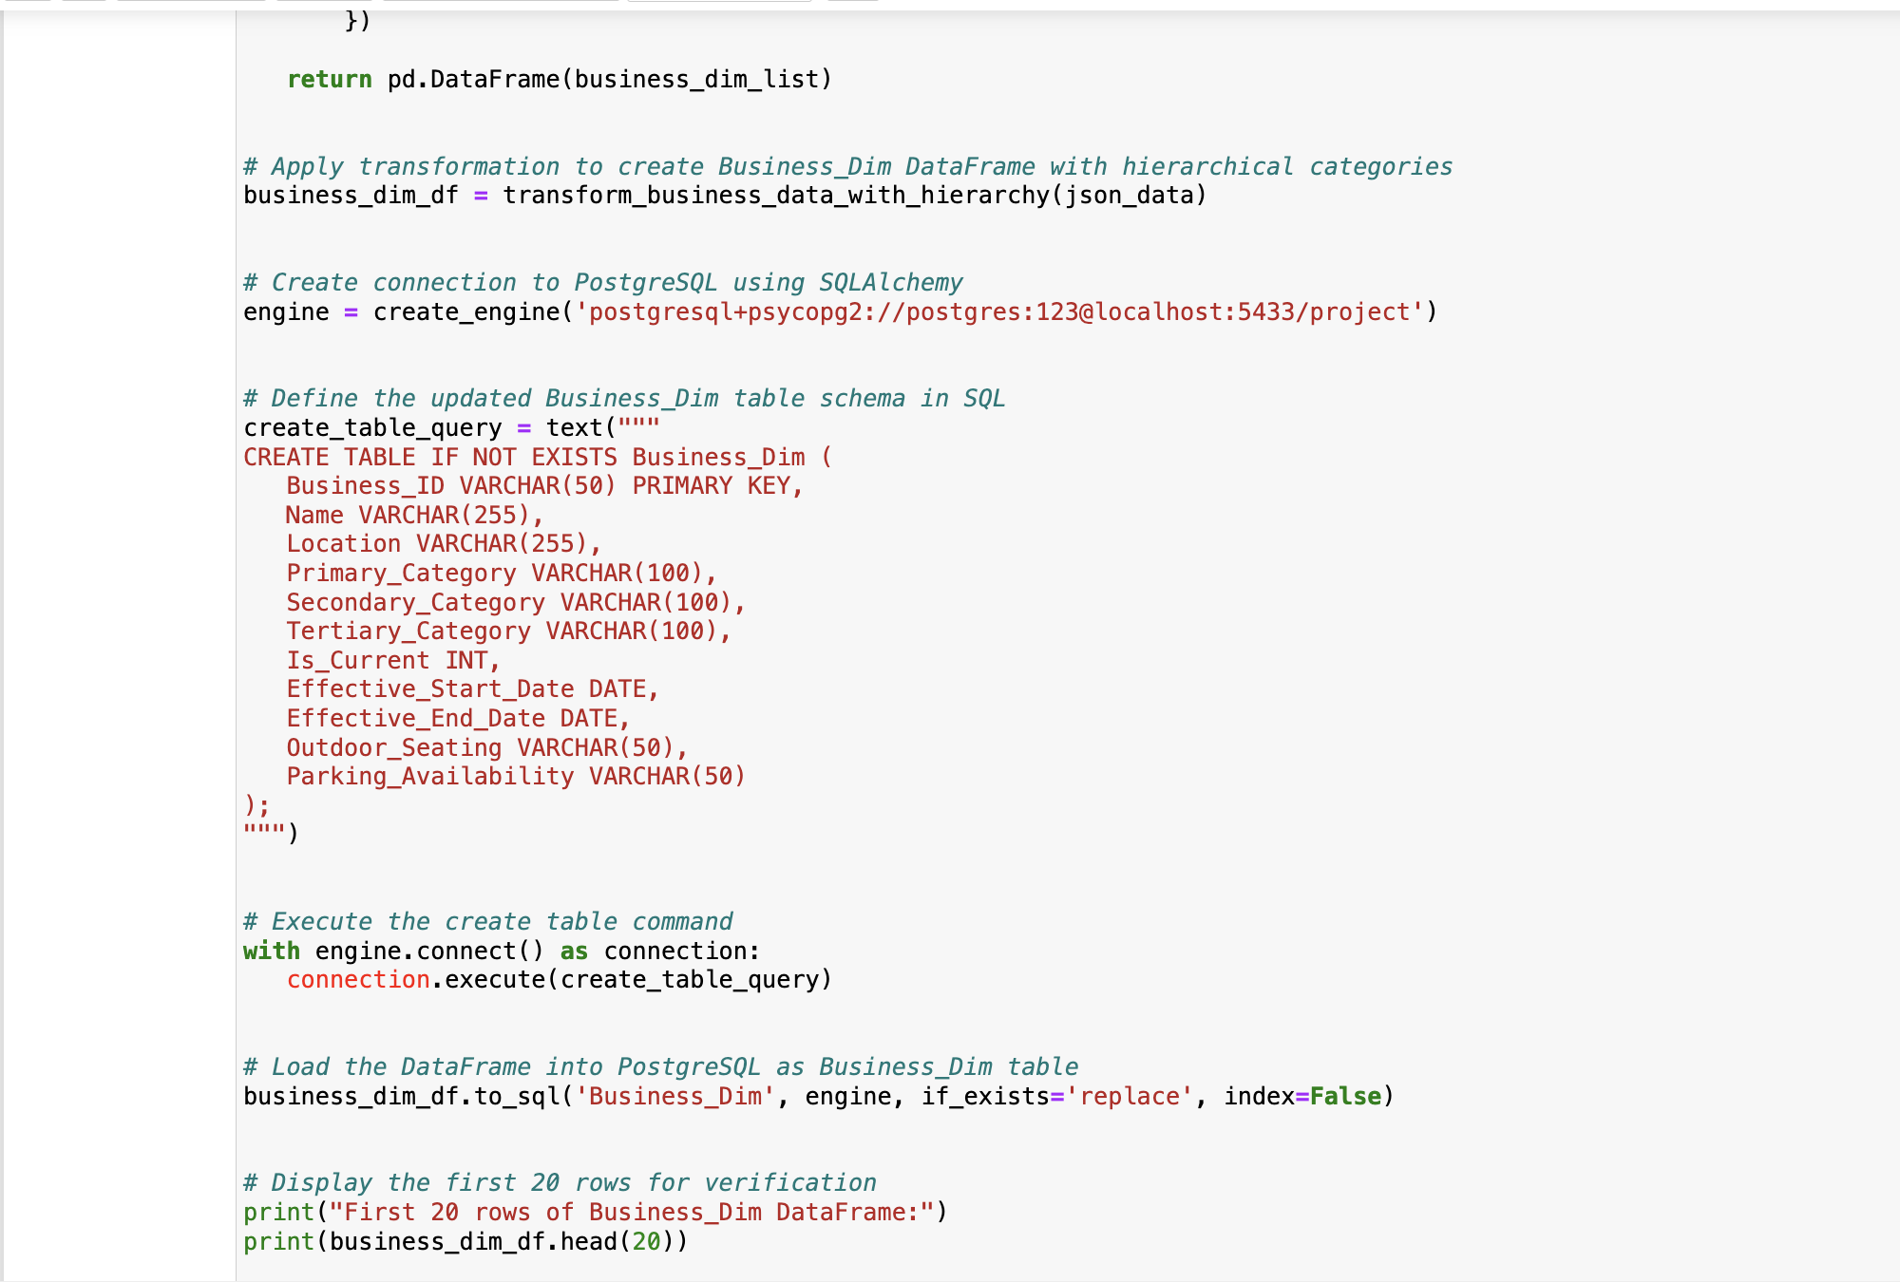

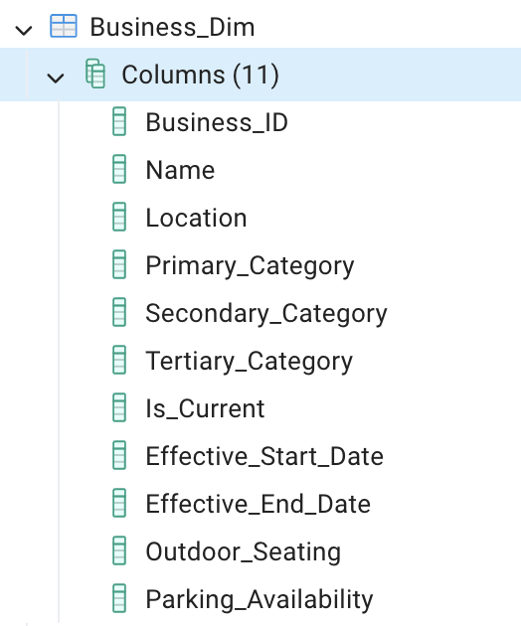

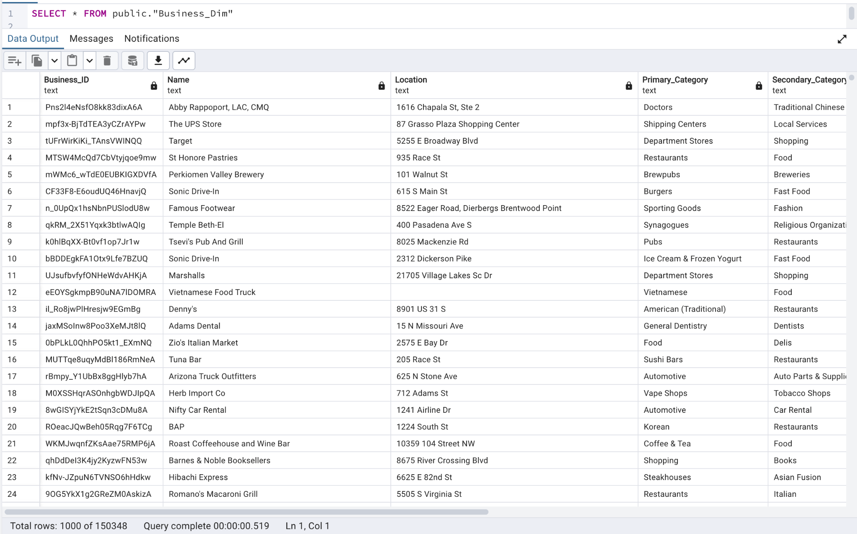

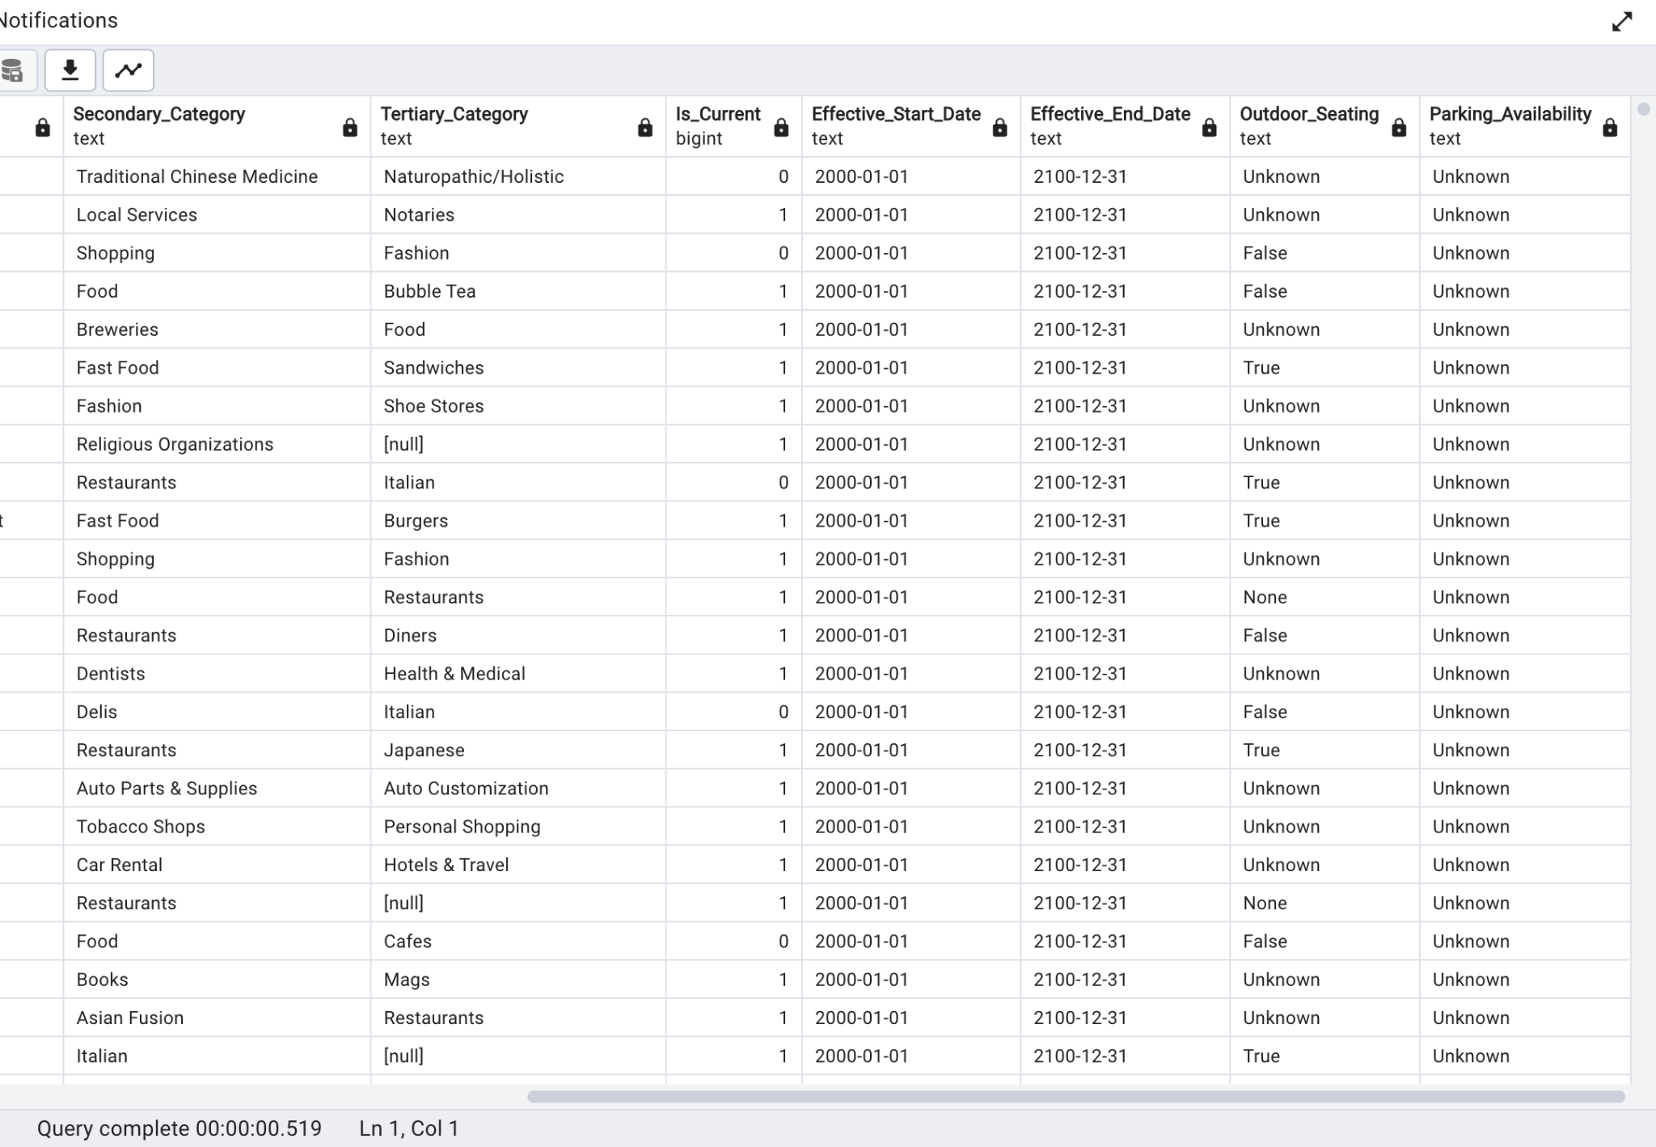

Load Date_dim

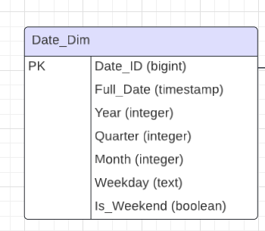

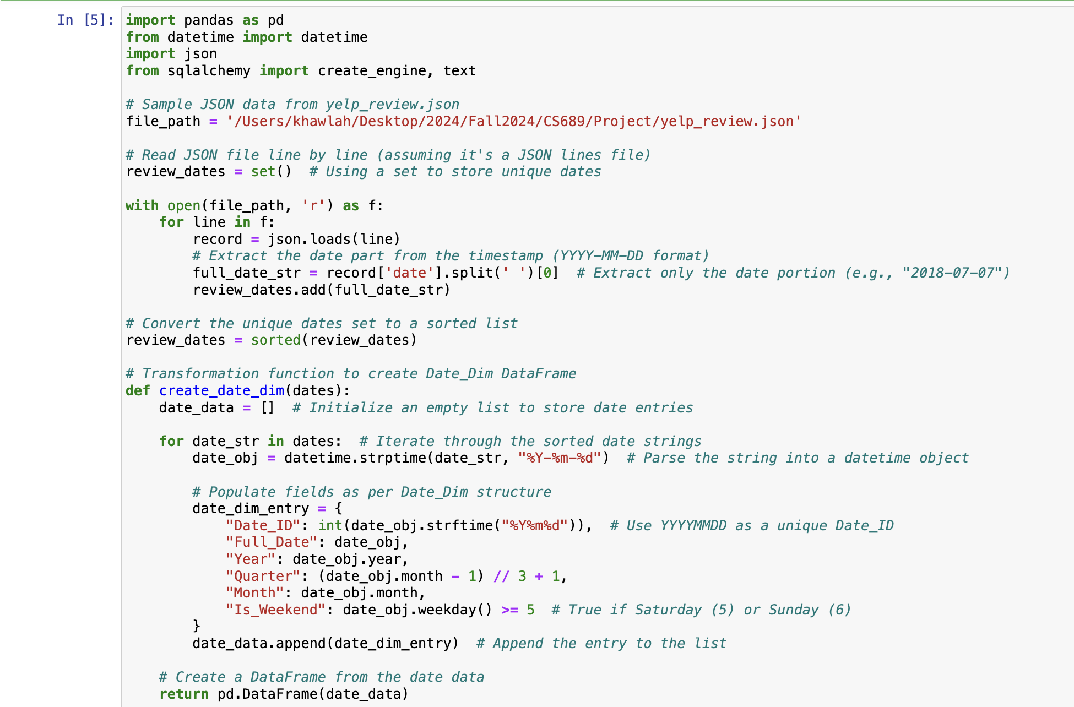

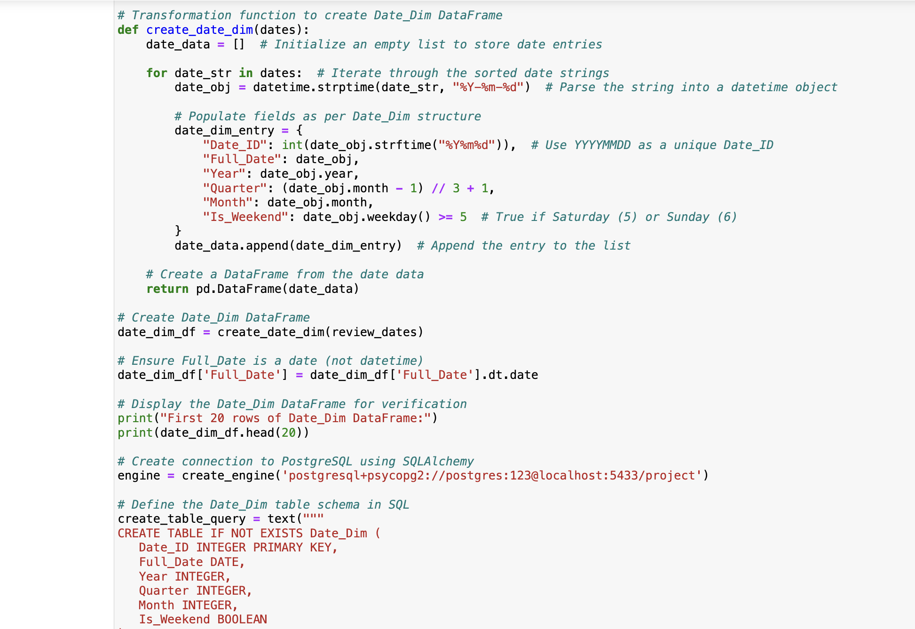

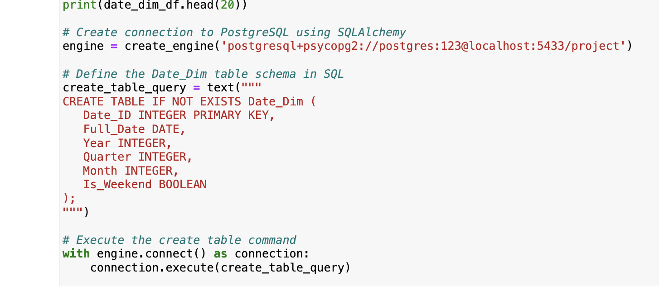

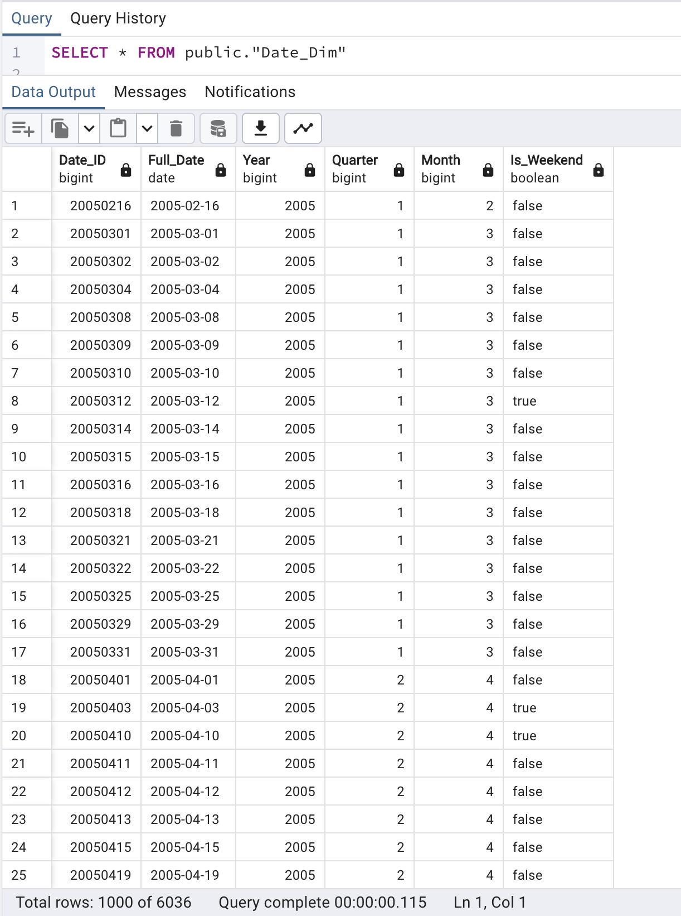

Added the Weekday column to the Date_Dim table using ALTER TABLE and then updated it with weekday values extracted from the Full_Date column using TO_CHAR

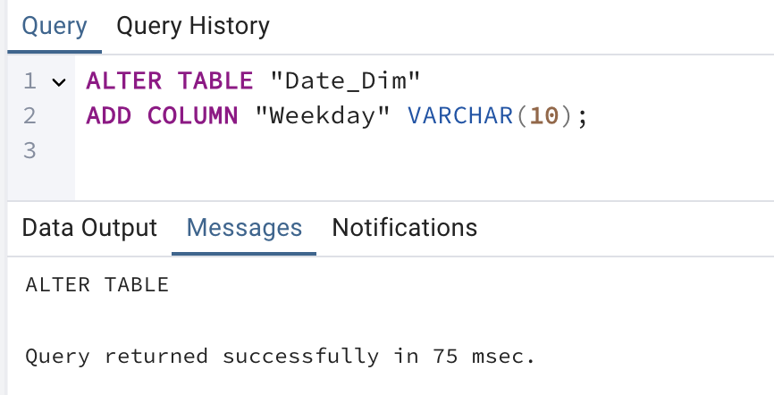

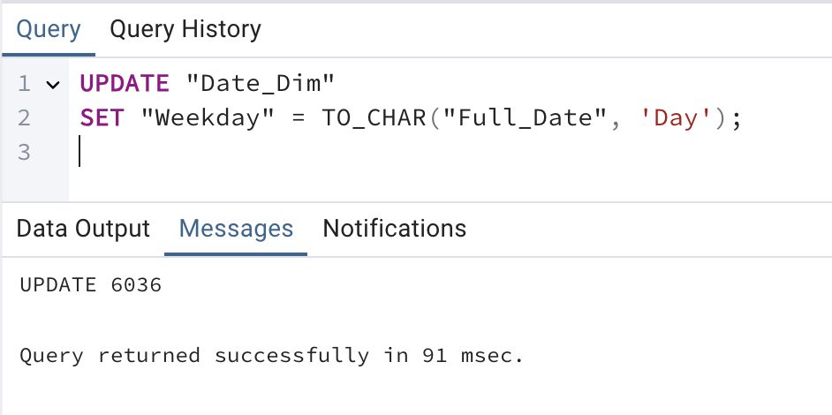

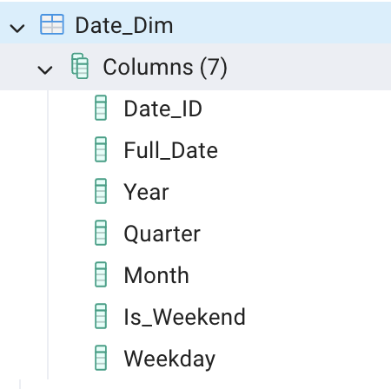

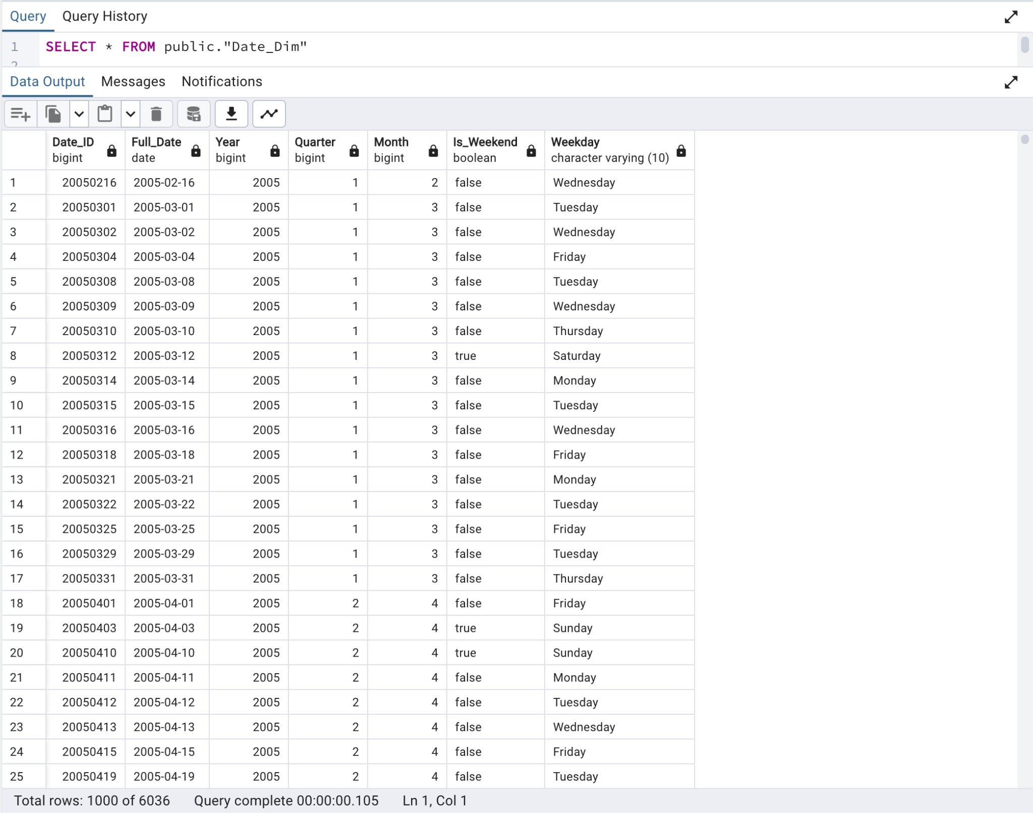

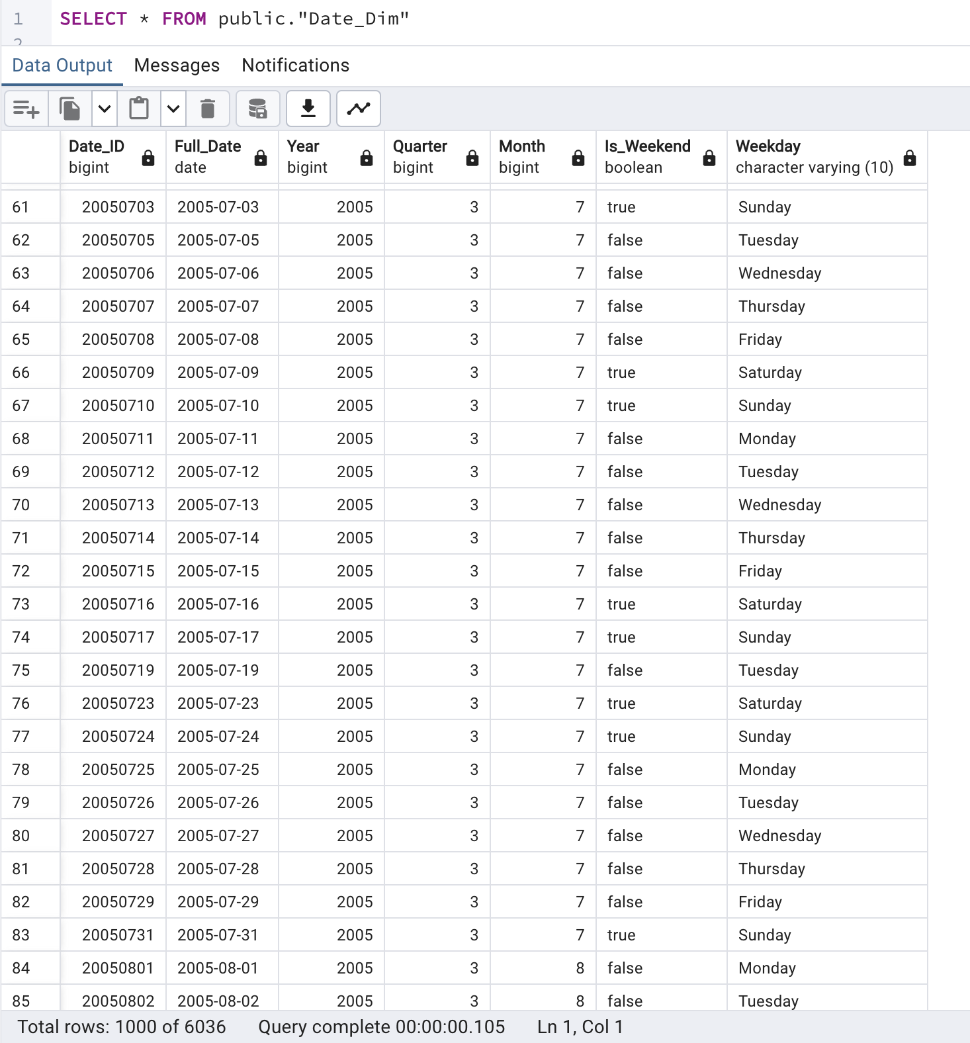

Create Time_Dim

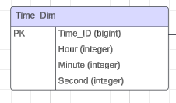

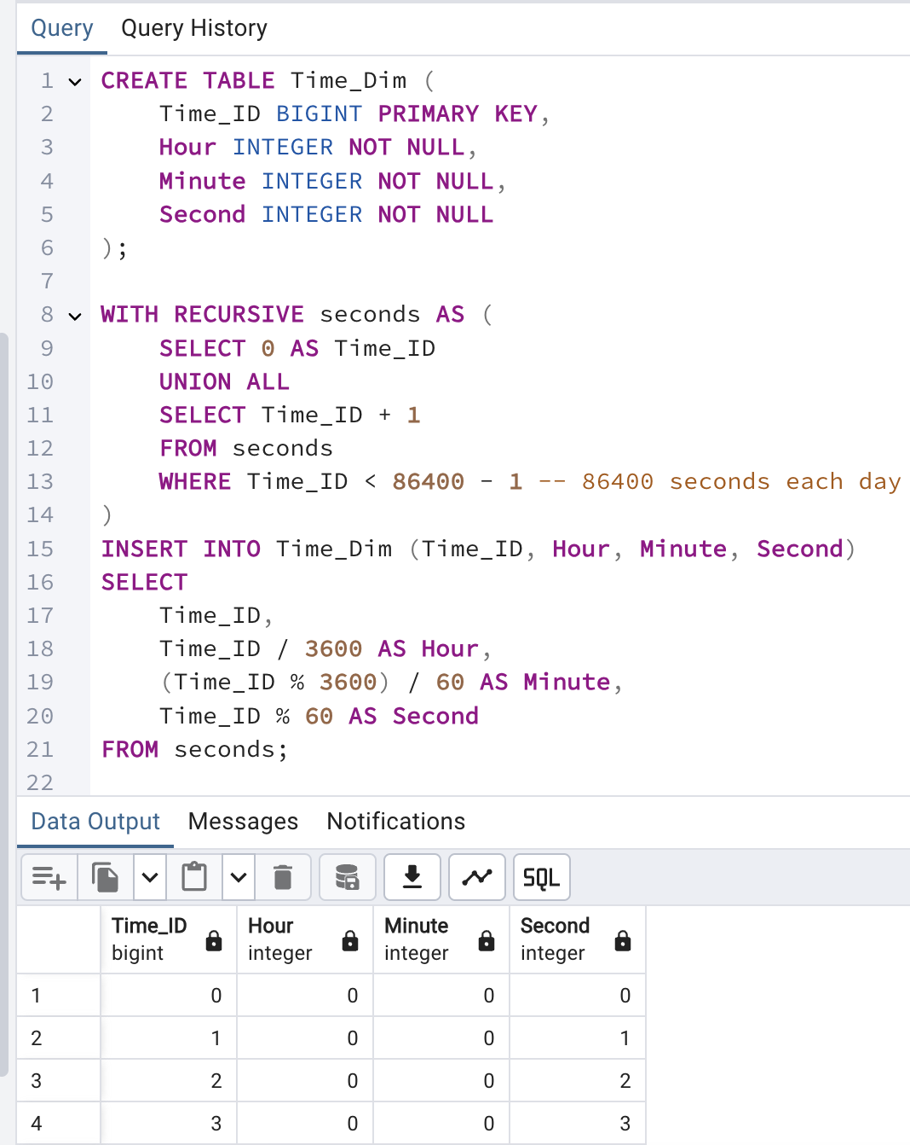

Load User_Dim

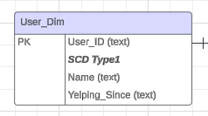

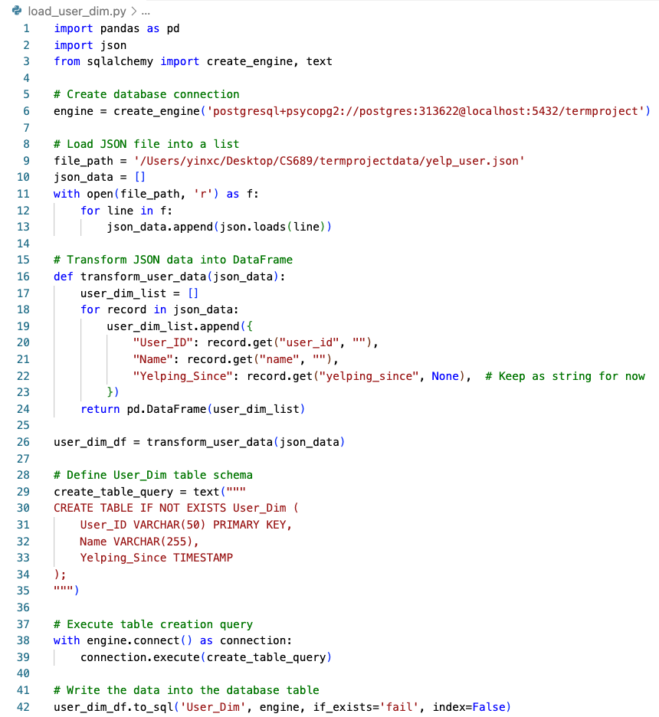

Load User_Fact

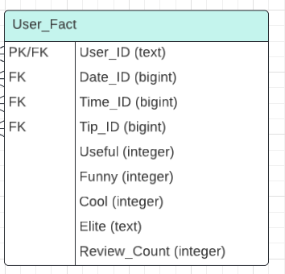

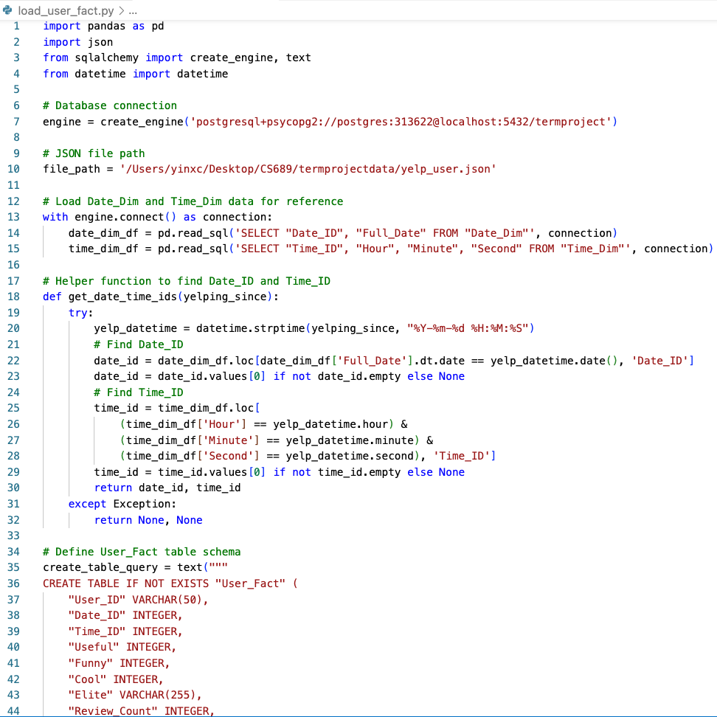

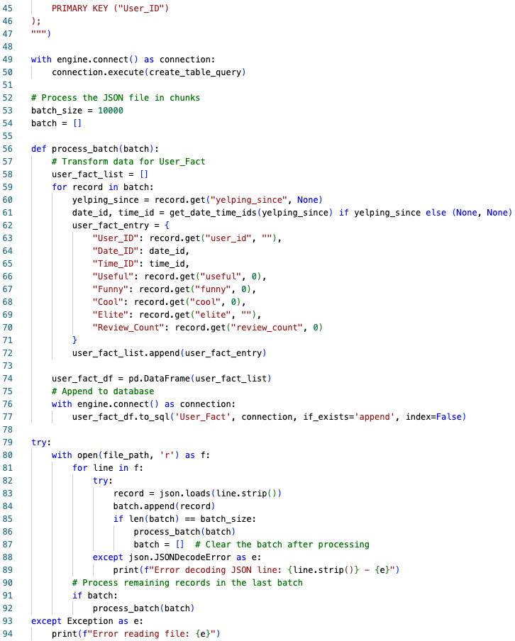

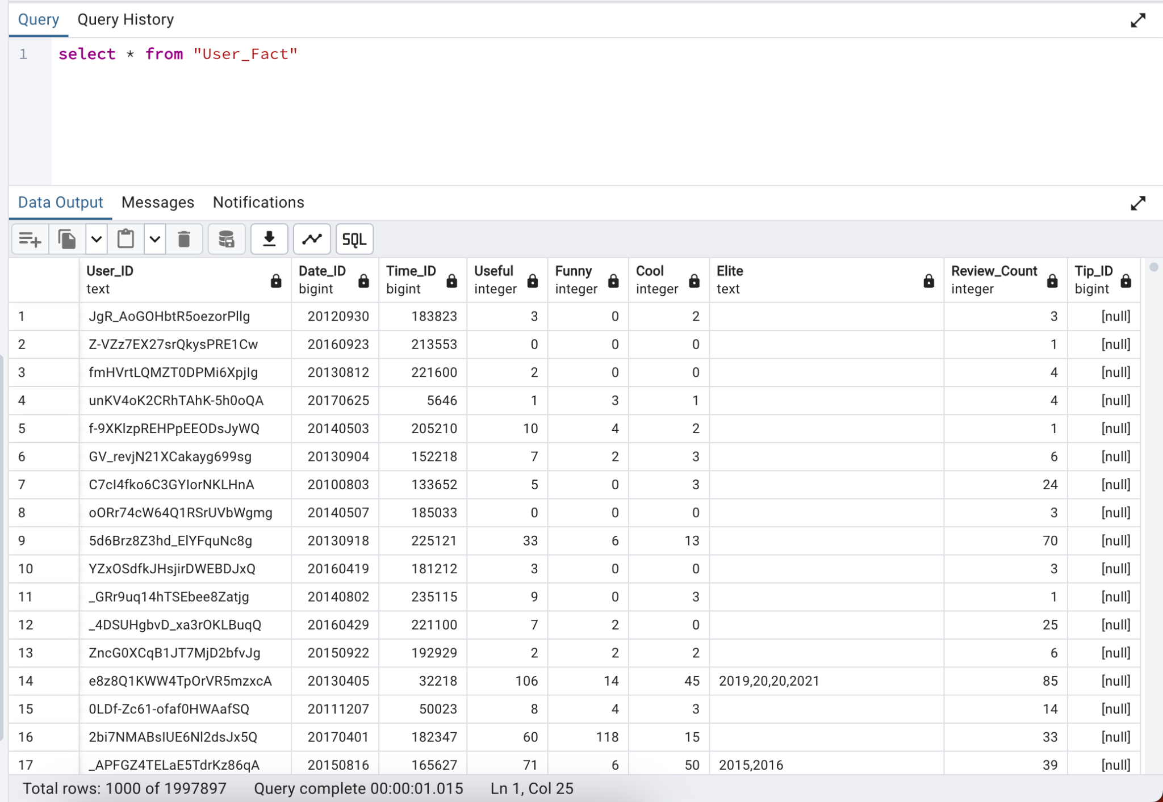

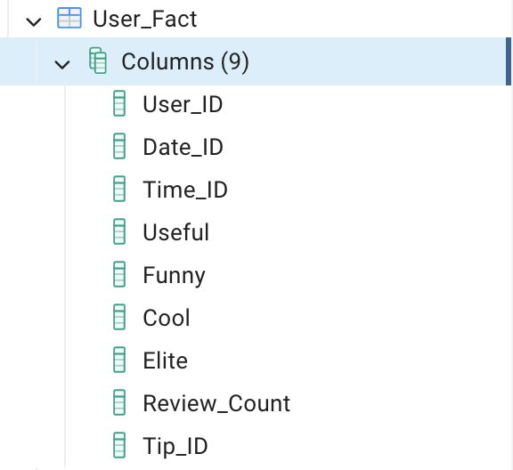

Load Location_Dim

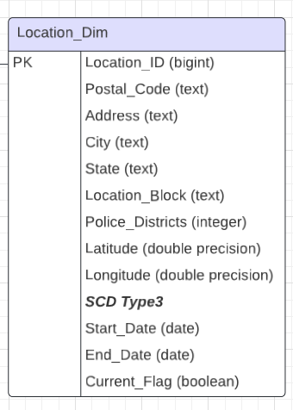

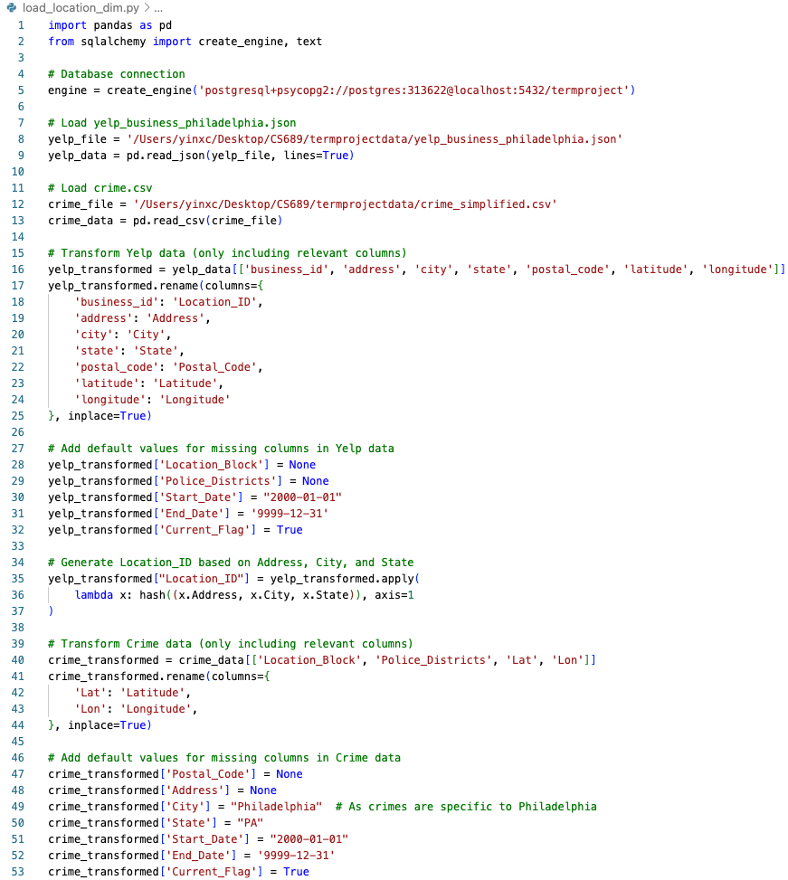

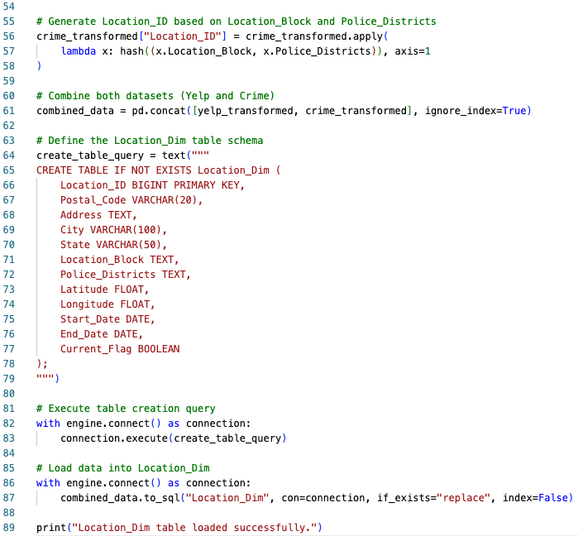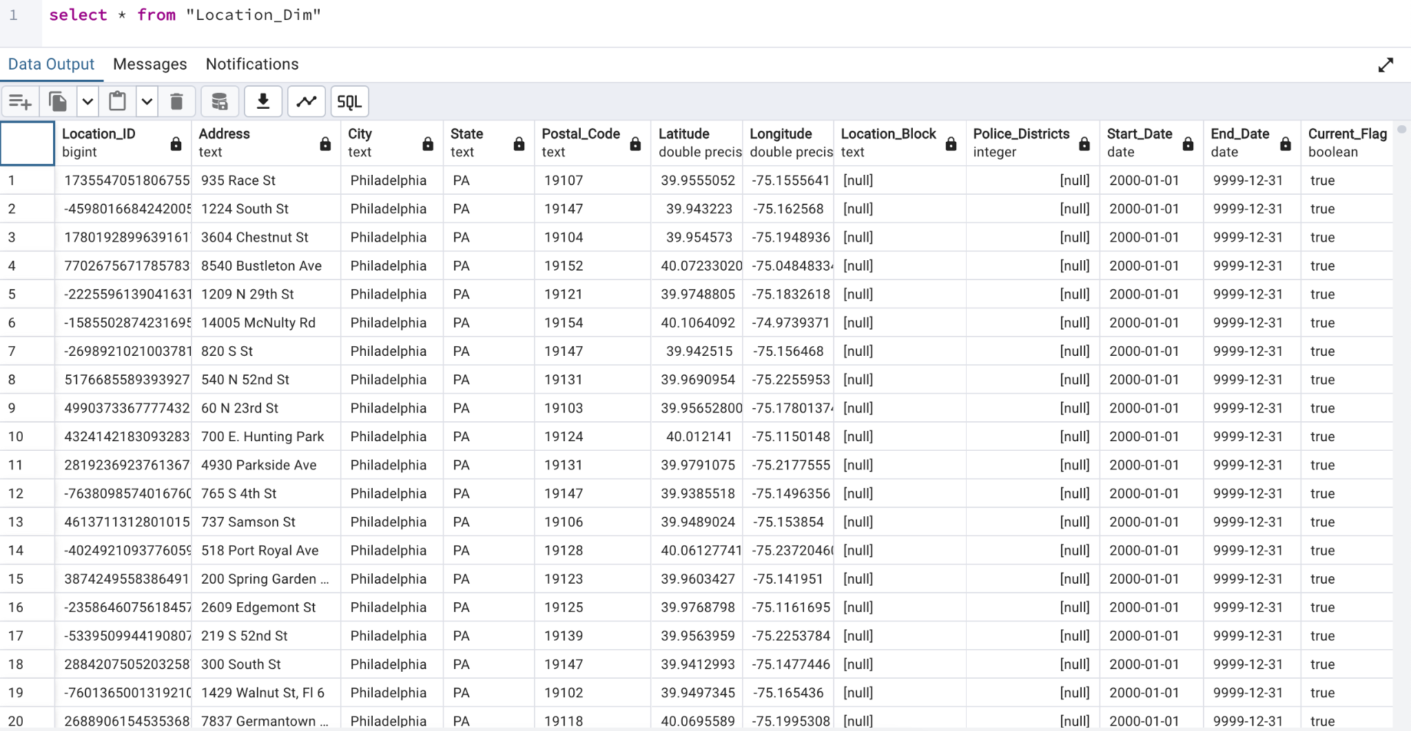

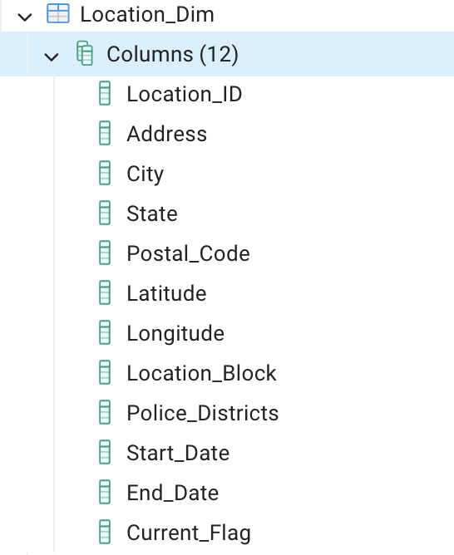

Load Tip_dim

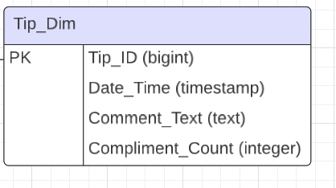

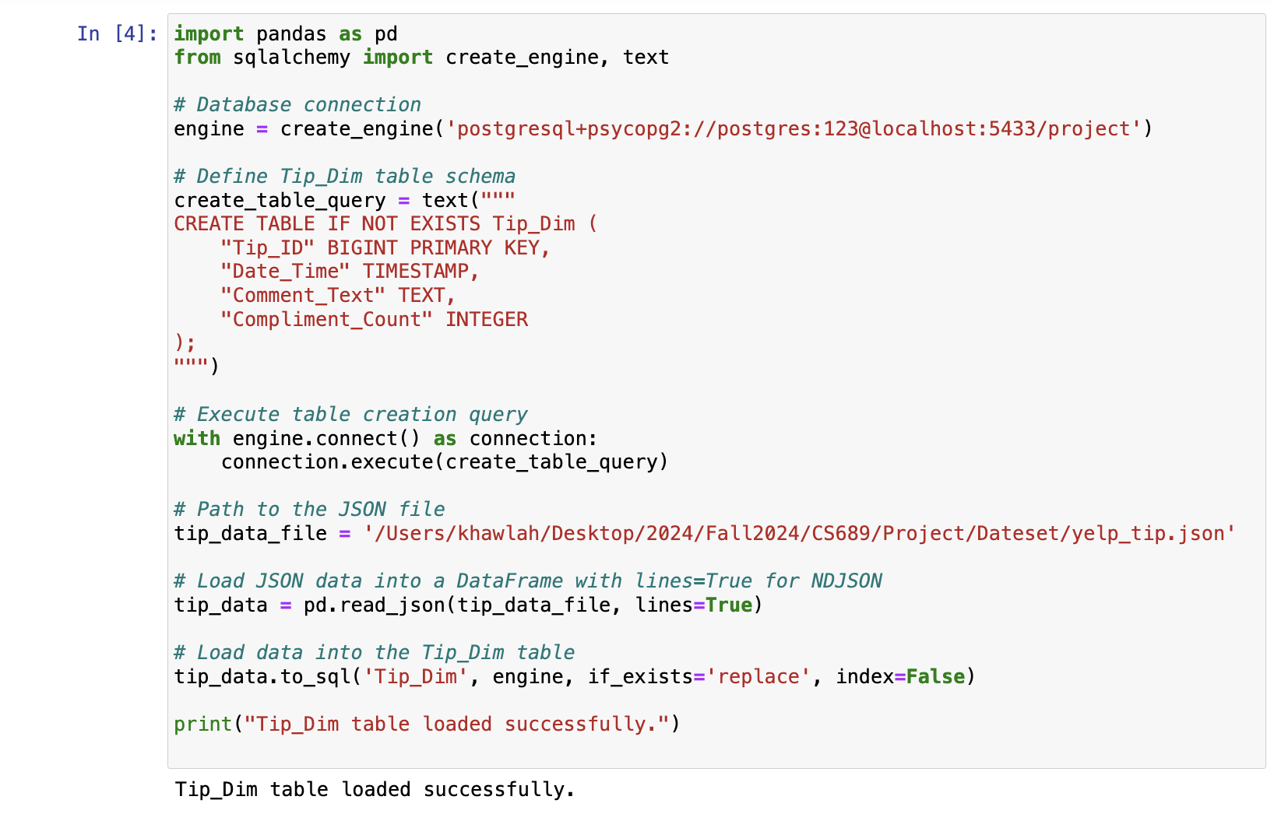

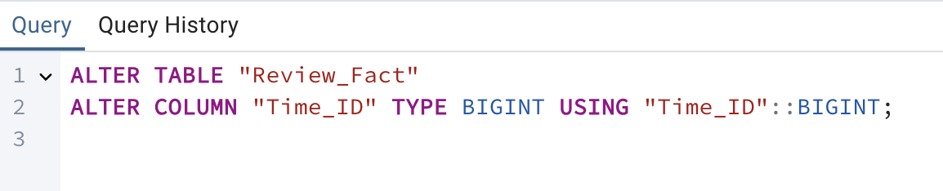

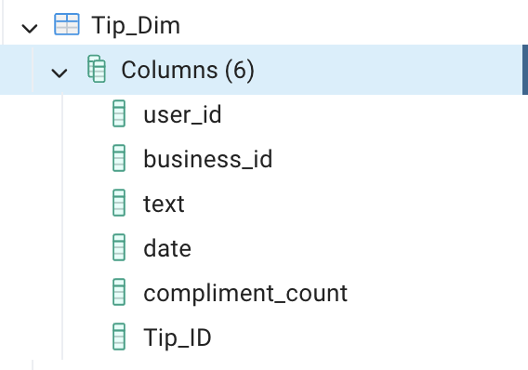

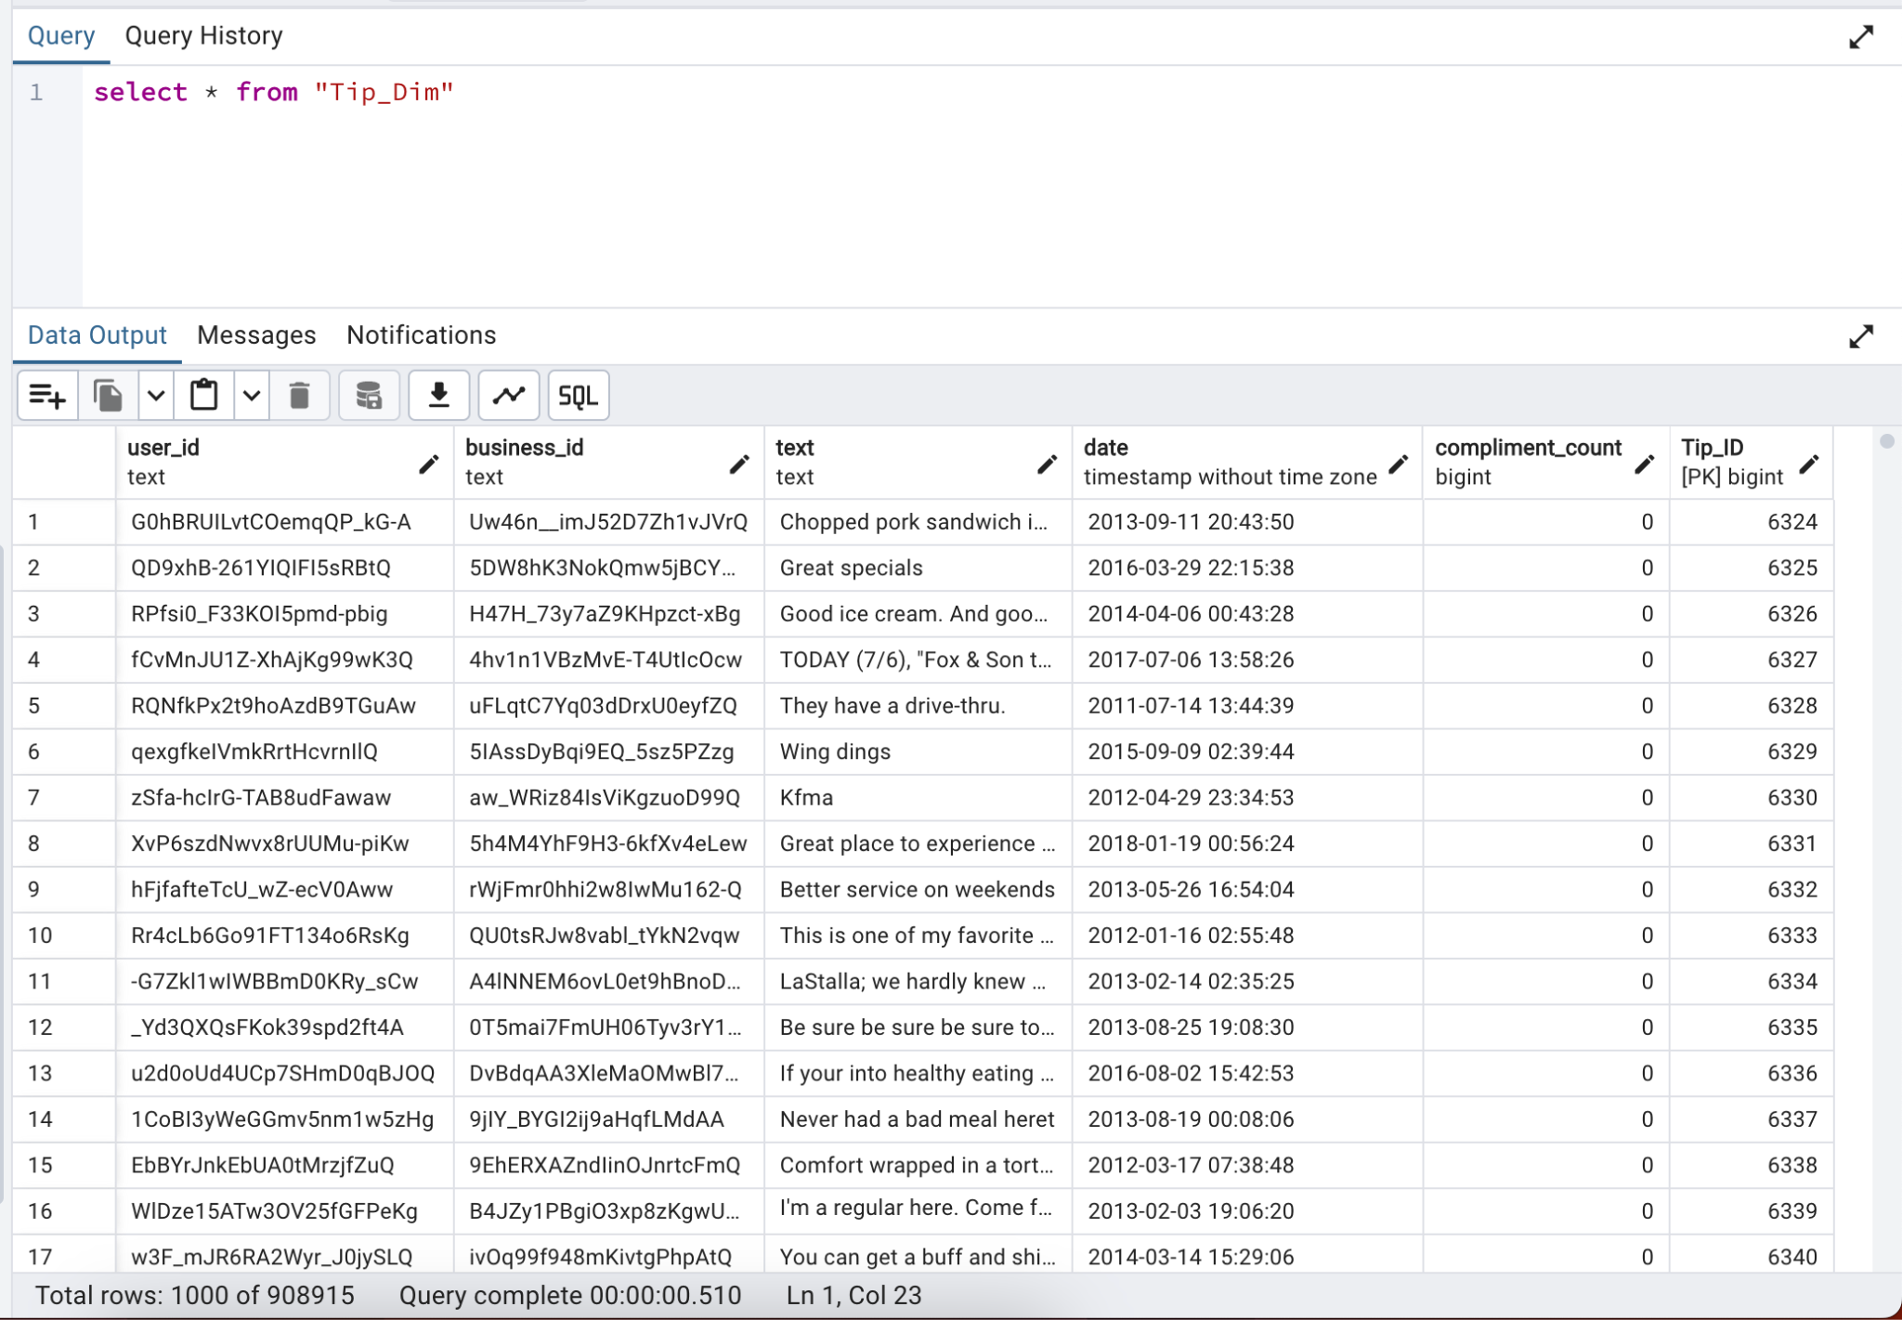

Load Review_Fact

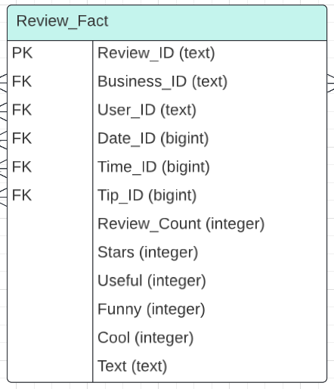

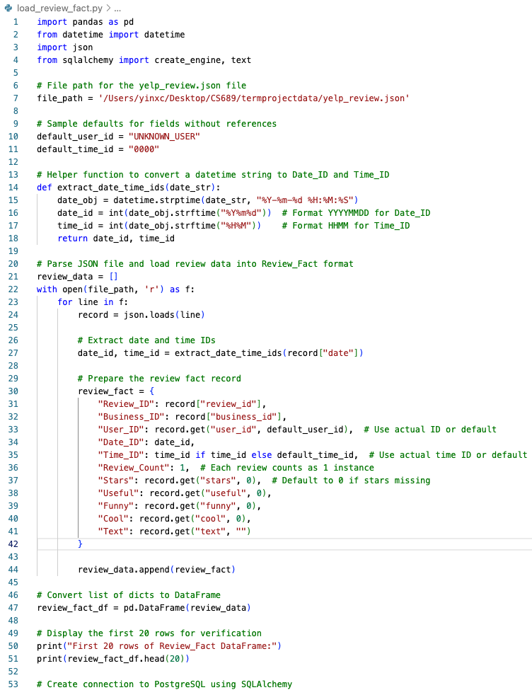

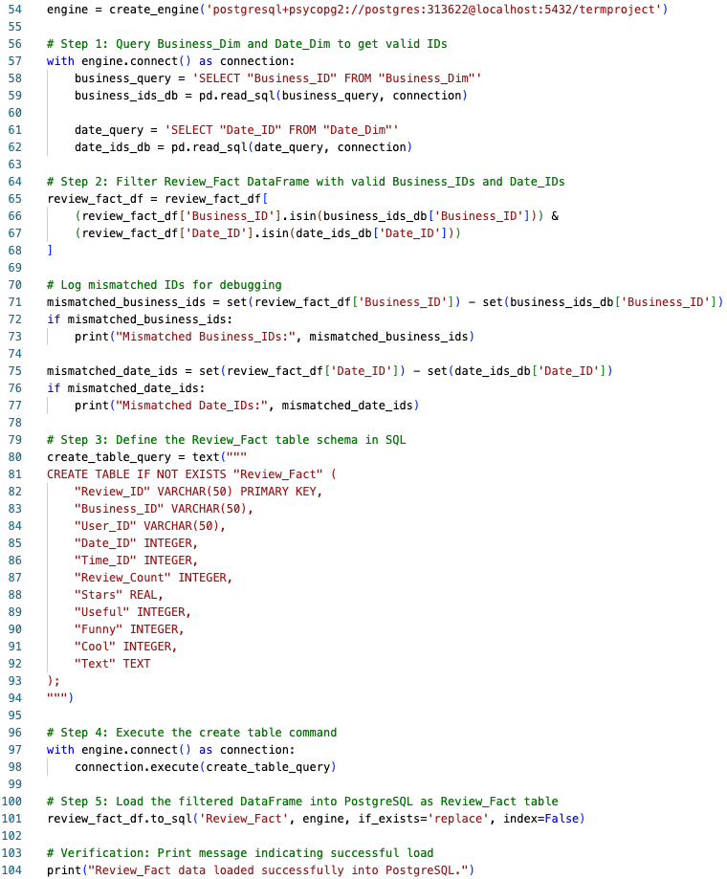

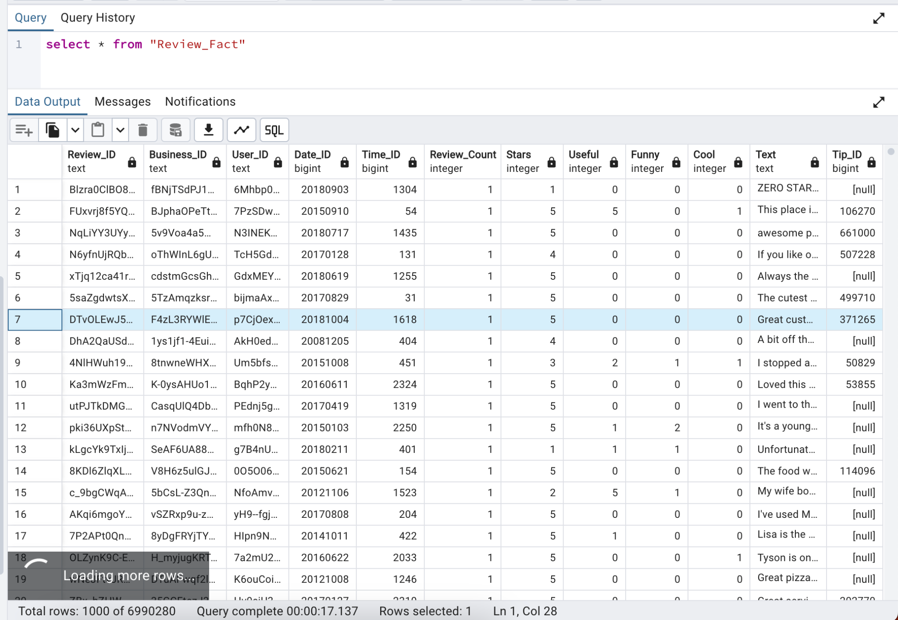

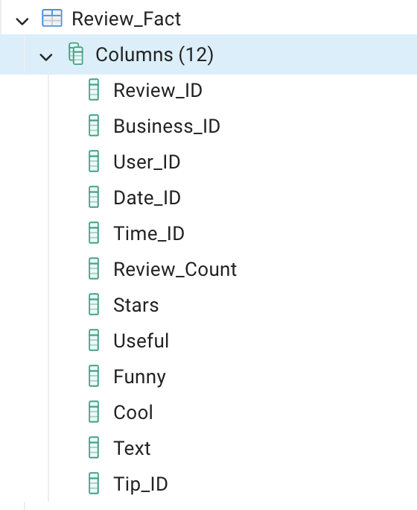

Load check-in Fact

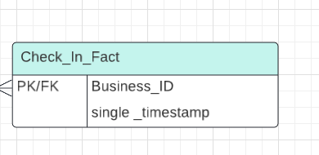

# 

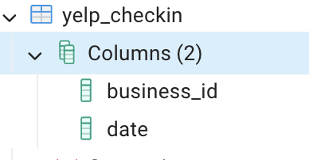

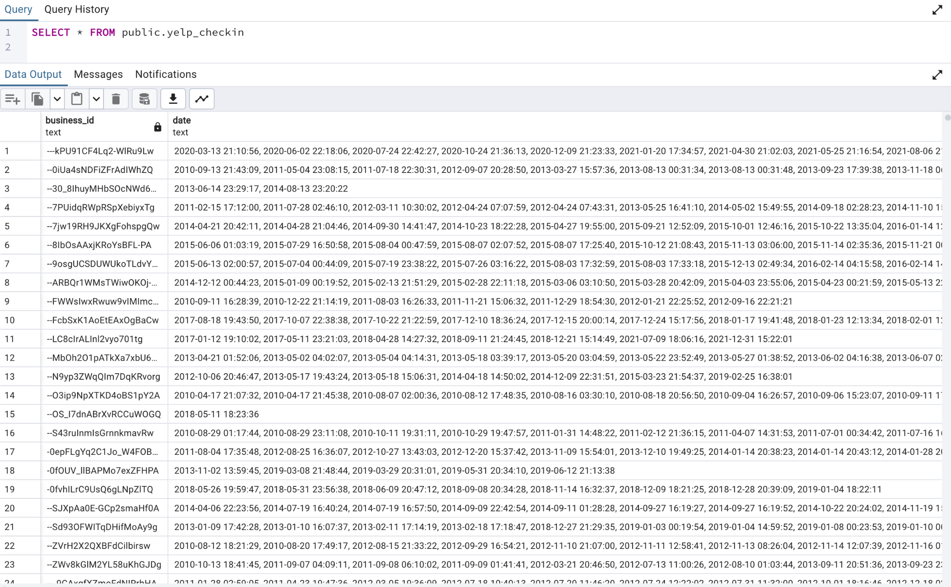

The dataset includes two columns:

1. **business_id**: Unique identifier for each business.
2. **date**: A string of timestamps separated by commas.

Creates a new table (yelp_checkin_cleaned) with the split rows stored in the database.

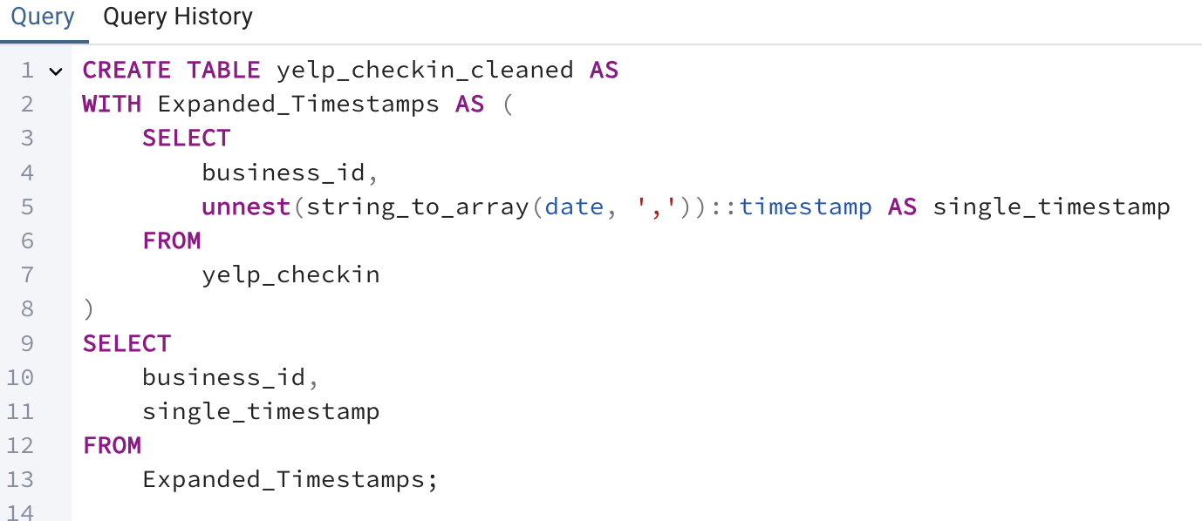

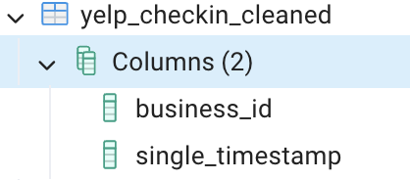

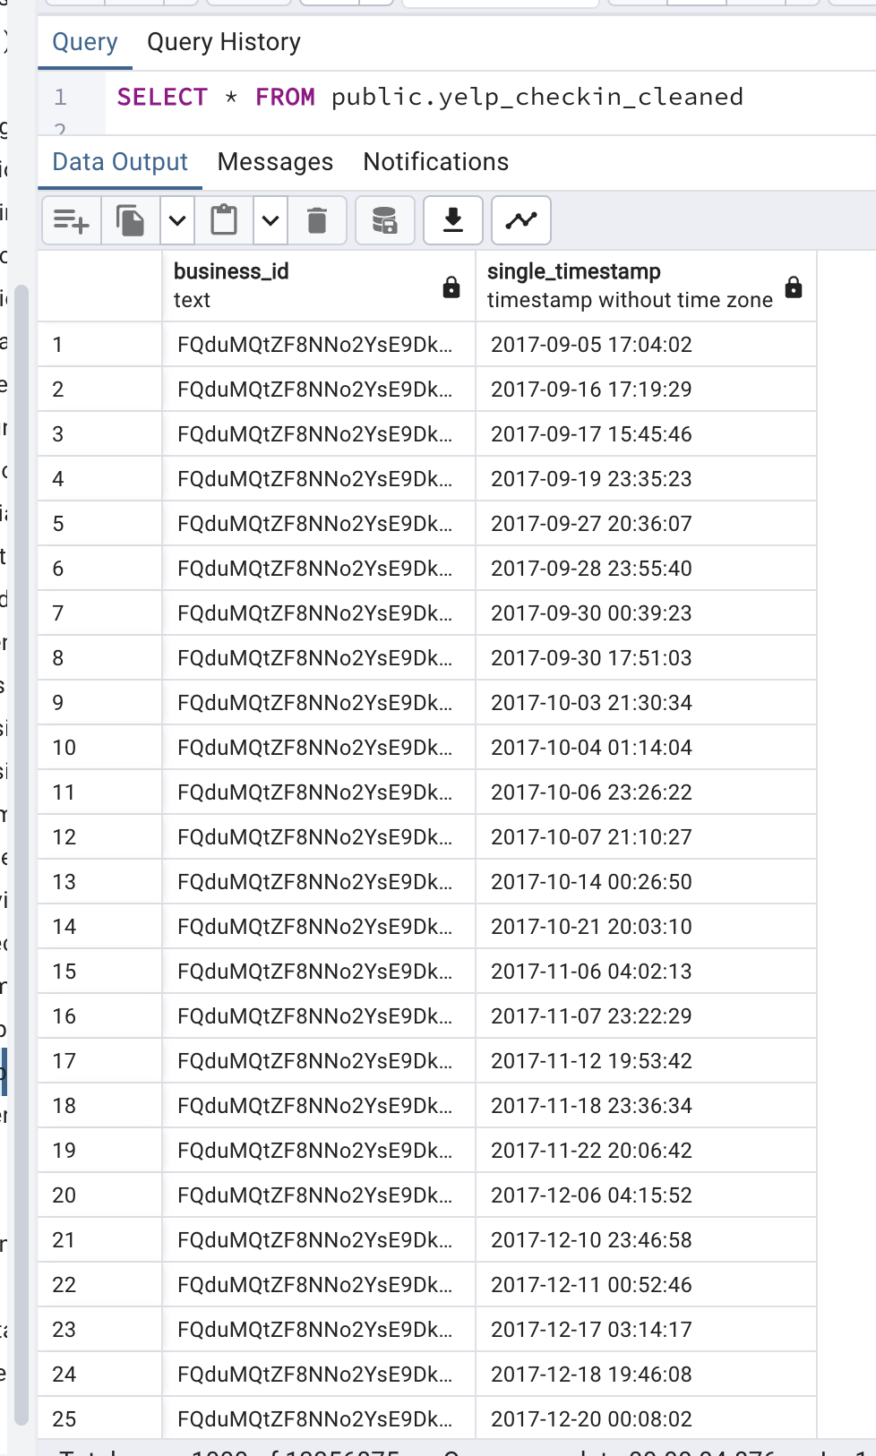

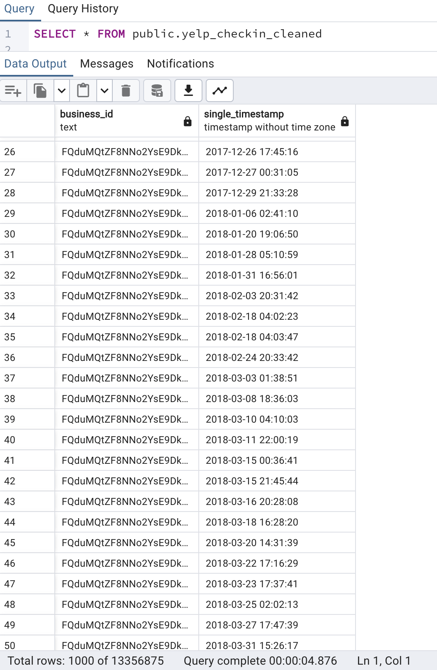

We create a new table **checkin_analysis** to analyze and summarize business check-in data from Yelp. The process involves multiple steps using Common Table Expressions (CTEs) to clean, process, and aggregate the data.

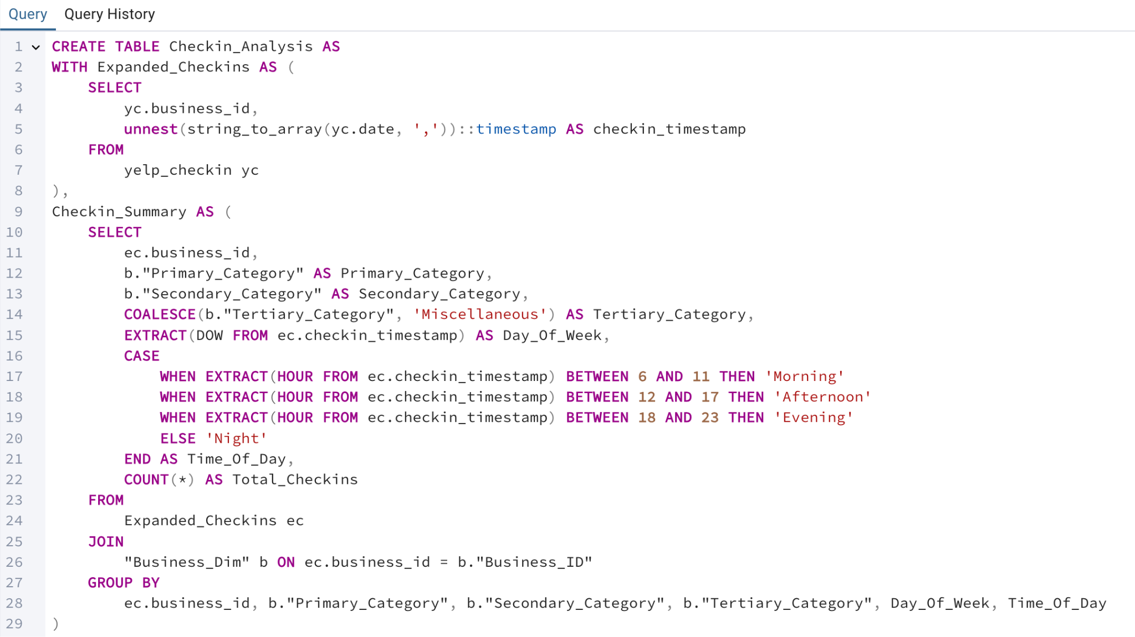

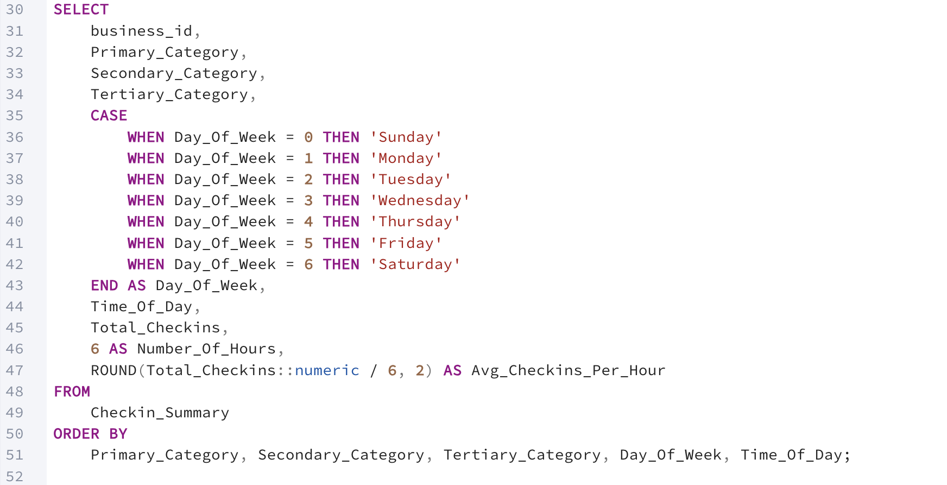

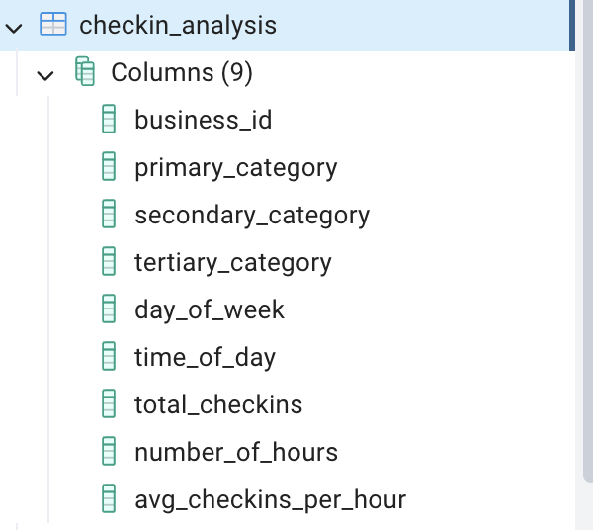

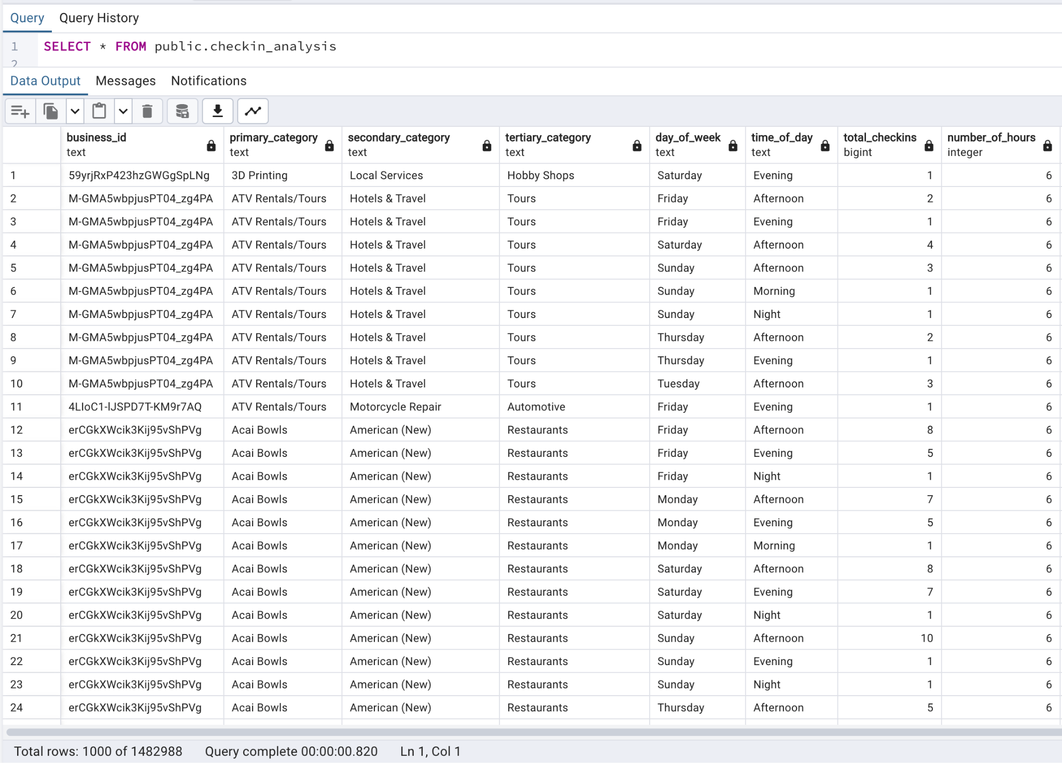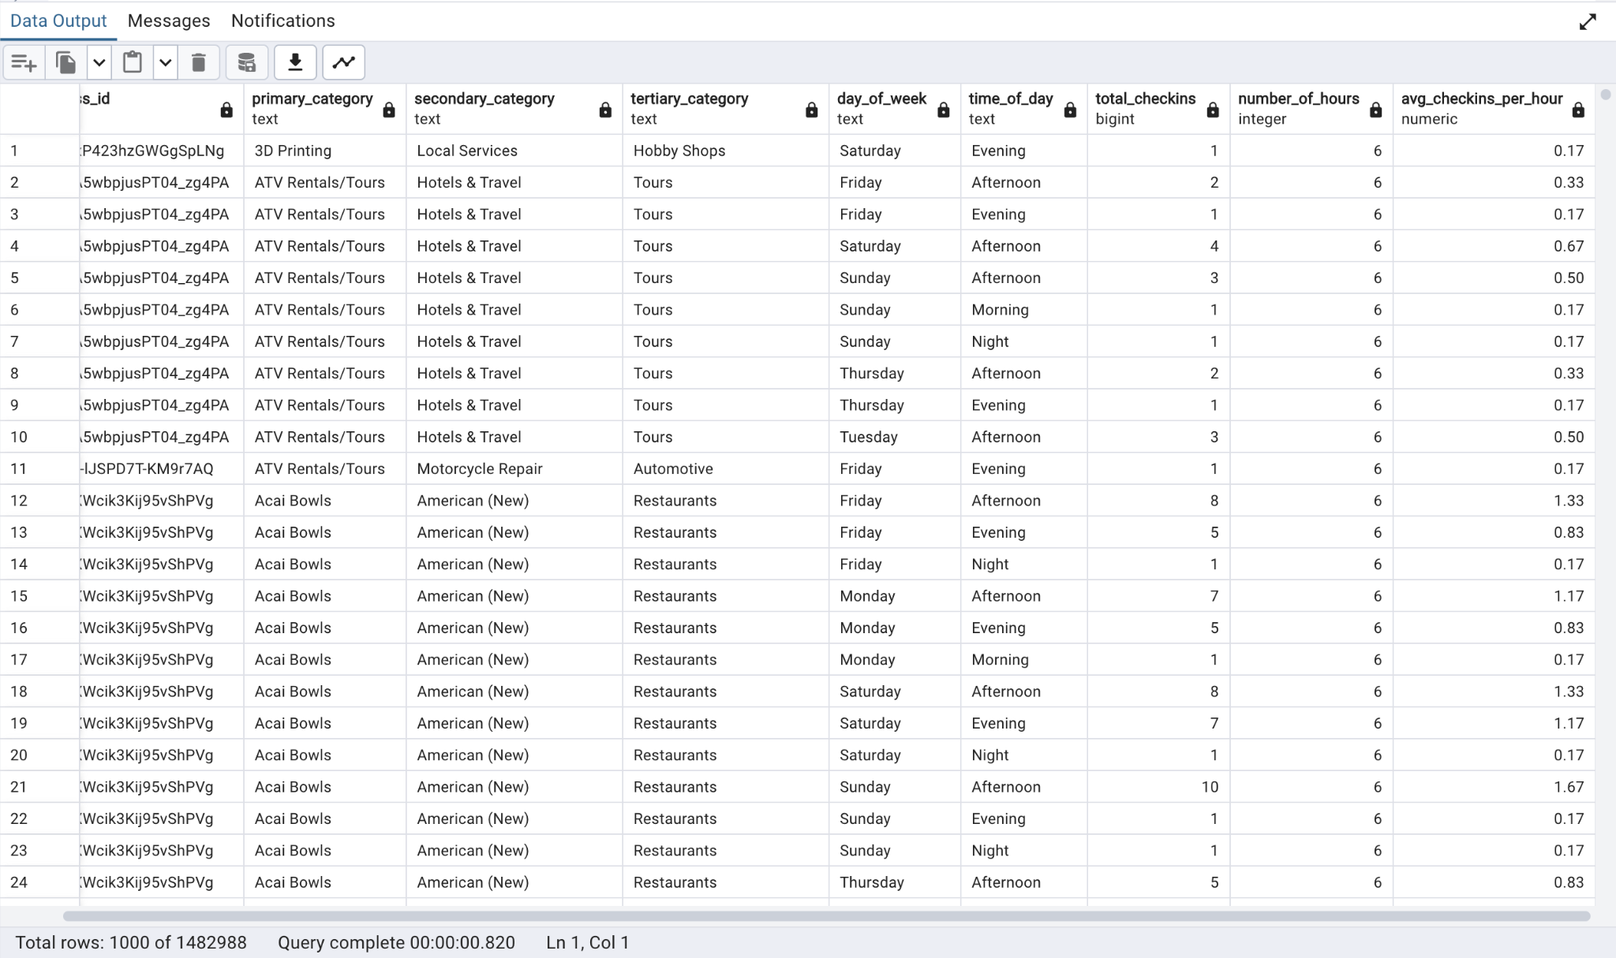

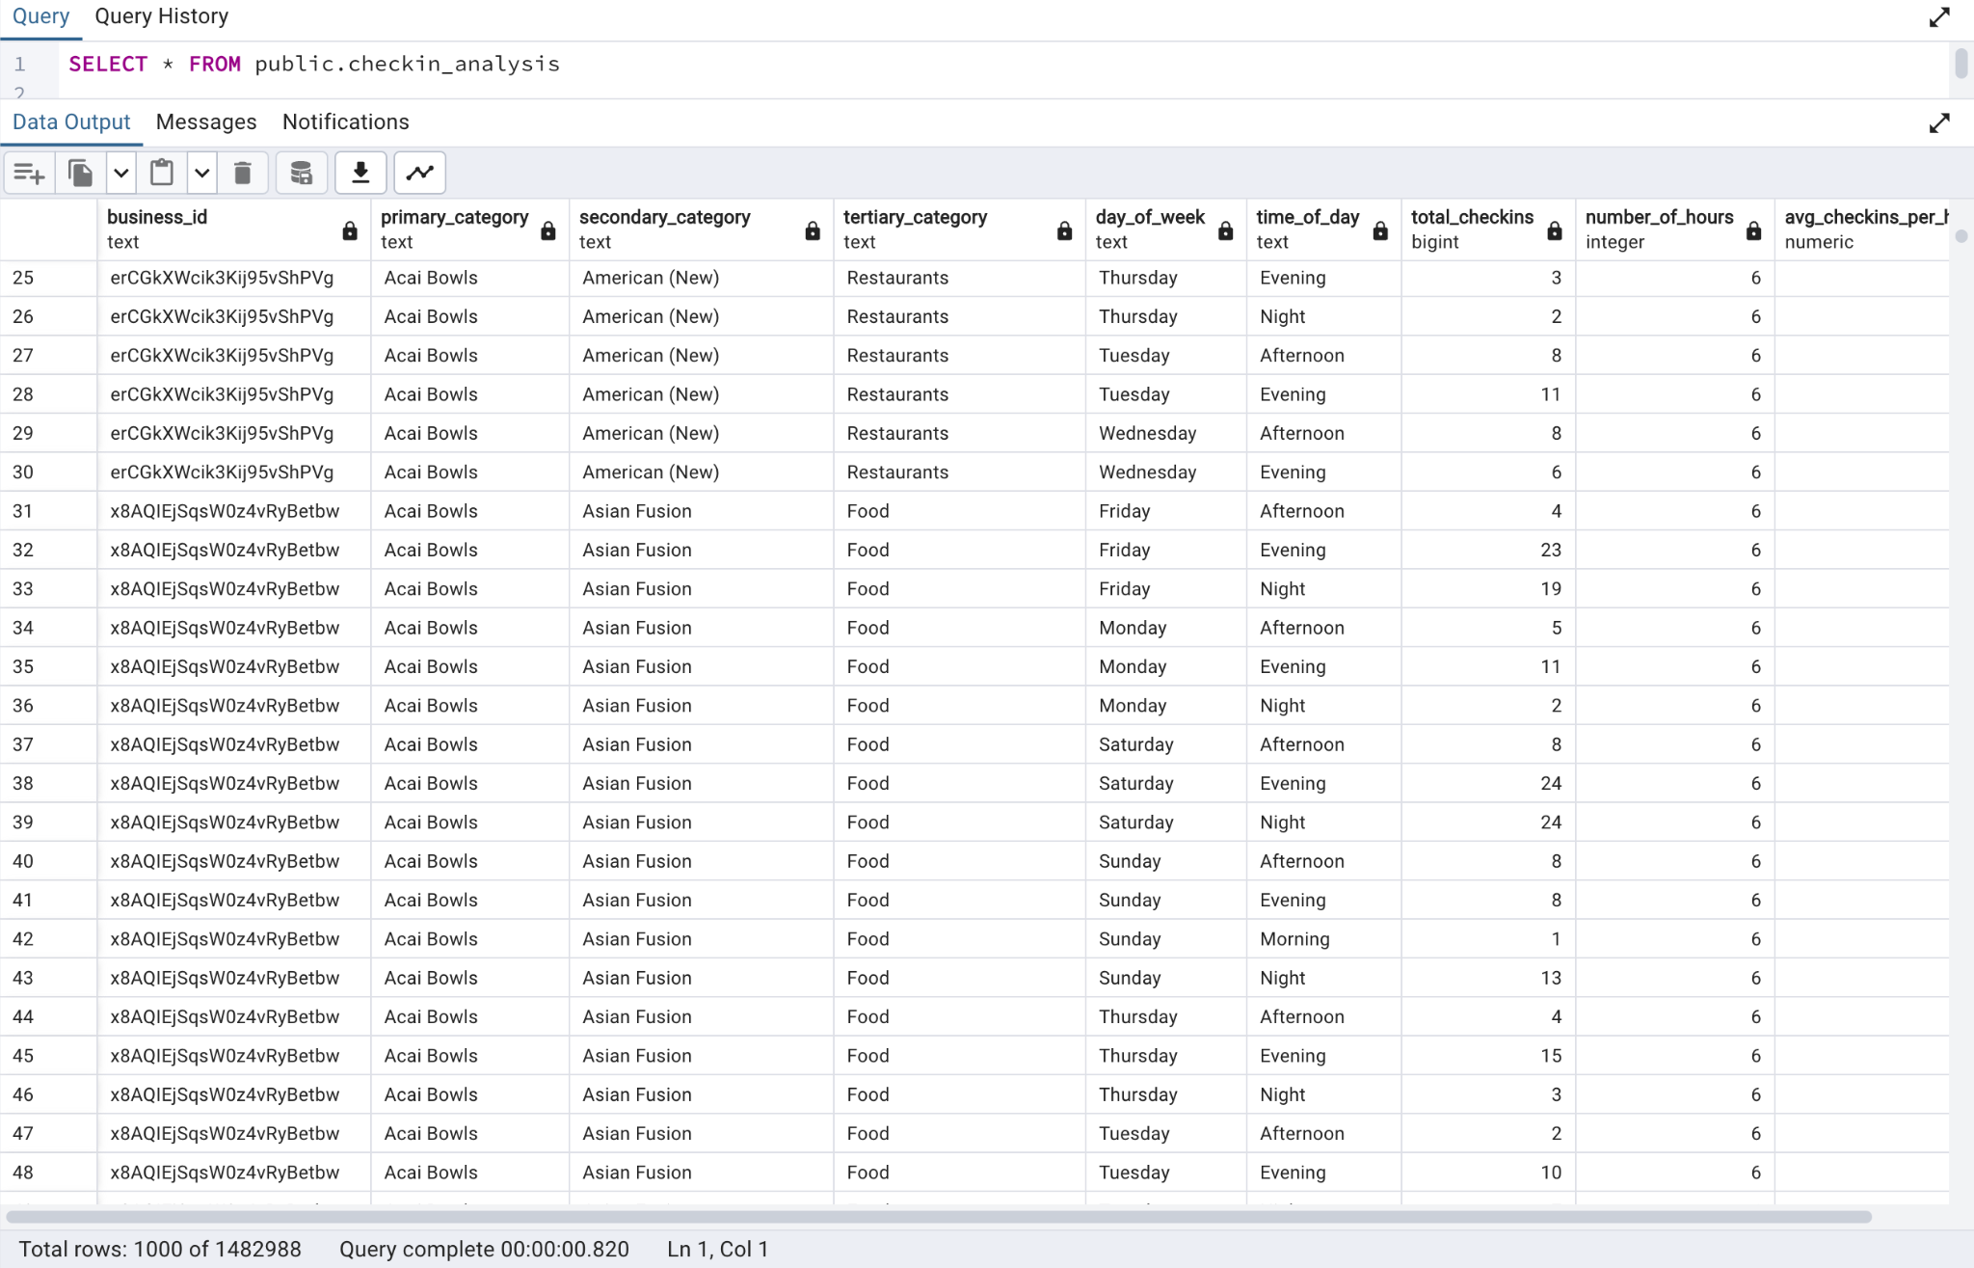

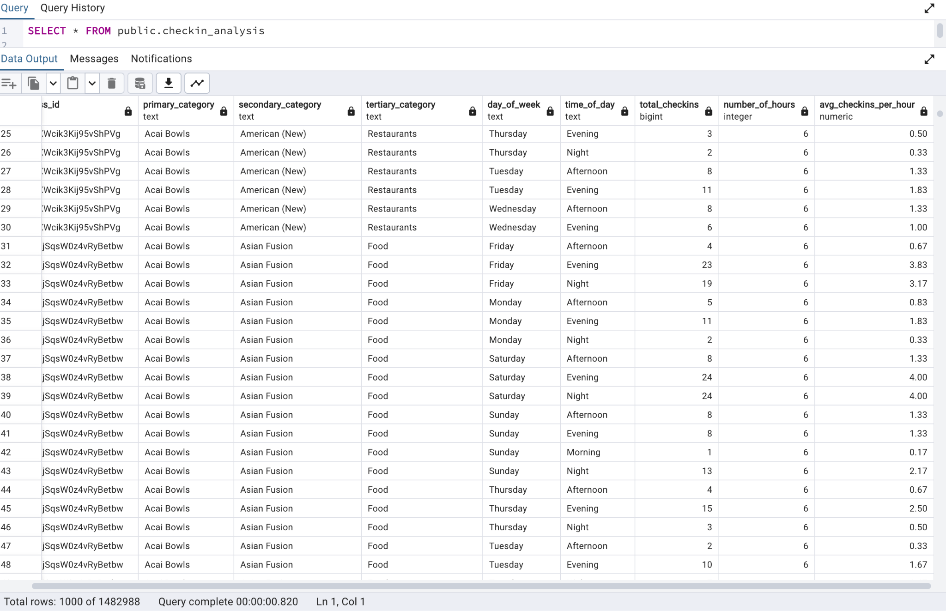

This table can help businesses understand customer trends and optimize their operating hours or marketing strategies based on peak activity times. For example:

* A coffee shop might see high "Morning" check-ins on weekdays.
* A bar might have higher "Evening" activity on Fridays and Saturdays.

Load Crime_Fact

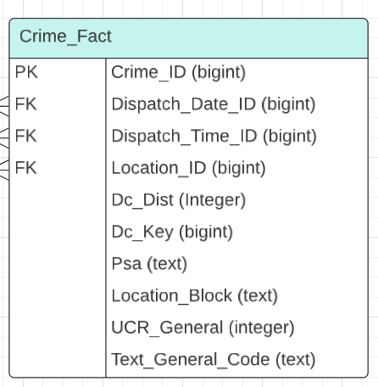

Because the crime.csv have too many data(More than 2 million rows) which makes the operations very slow, we make it small by delete the data with the row that is multiple of 2 several rounds:  
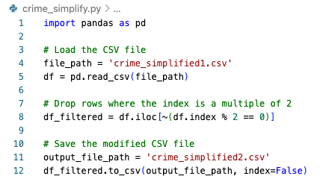

Change the file path with: crime.csv & crime_simplified1.csv and then crime_simplified1.csv & crime_simplified2.csv, then crime_simplified2.csv & crime_simplified1.csv, then crime_simplified1.csv & crime_simplified2.csv…

we make the data to be around 40,000 rows.

Then load the data:

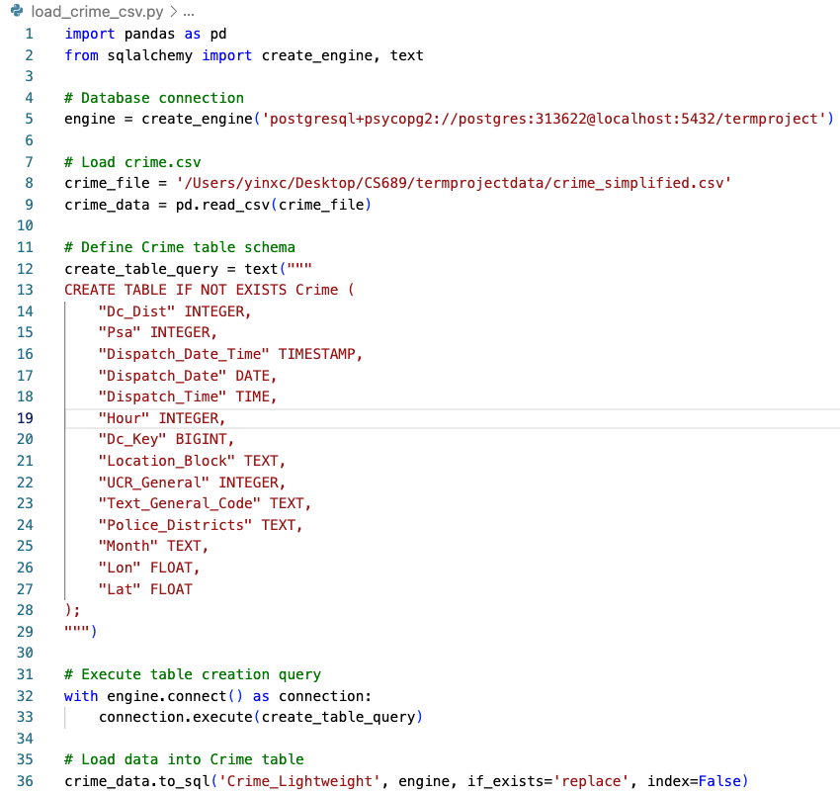

Then Transform to be Crime_Fact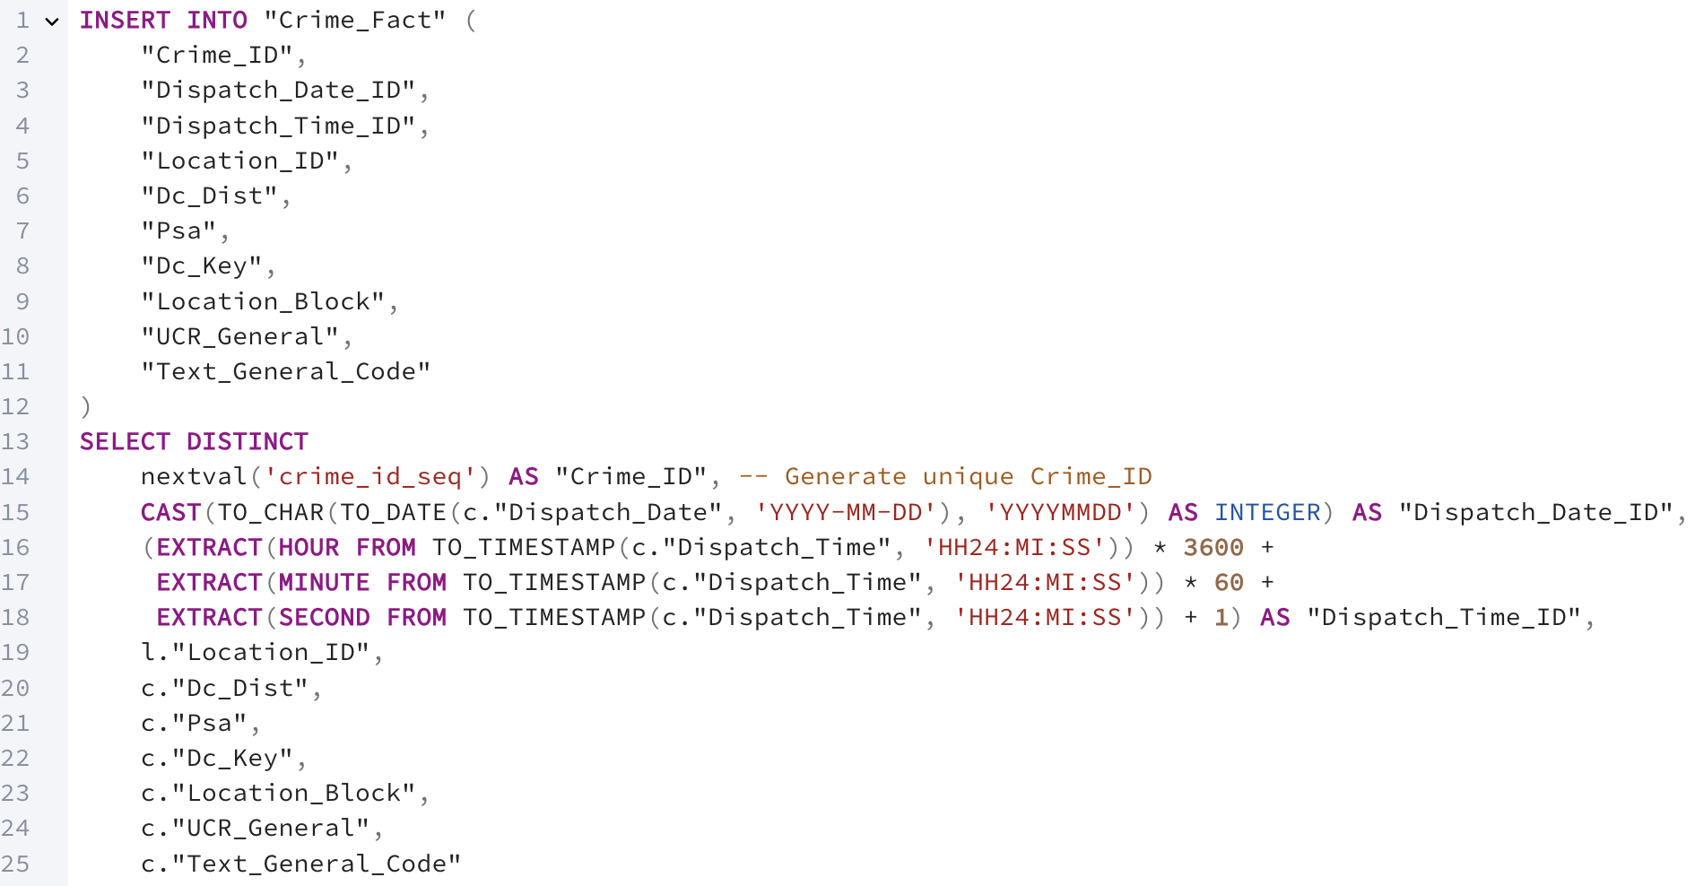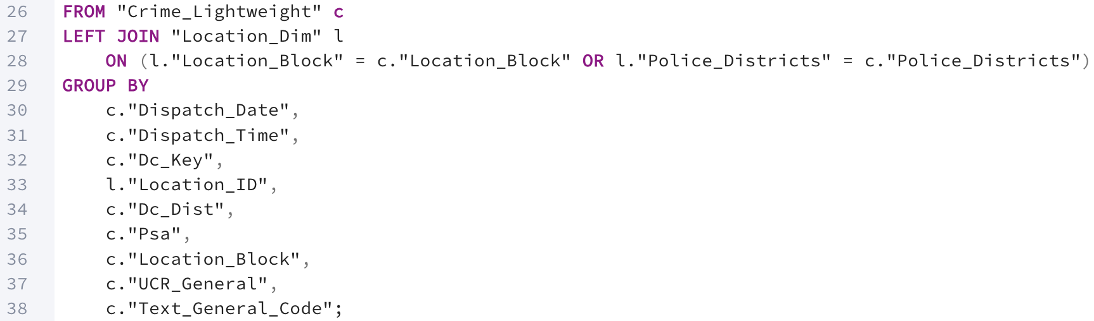

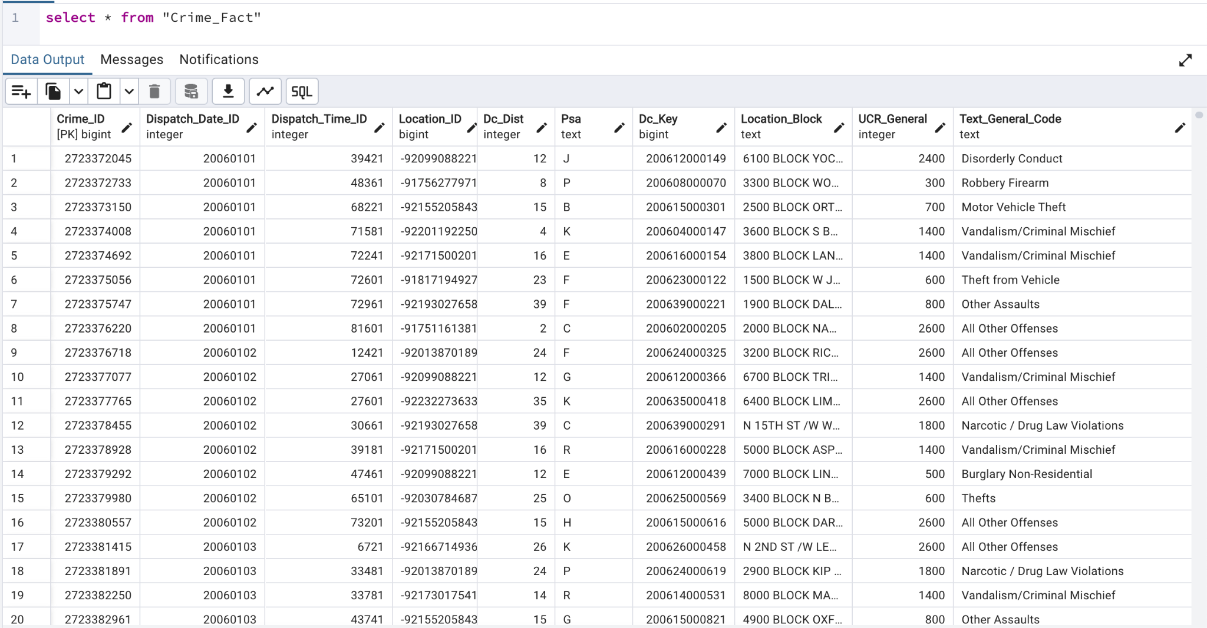

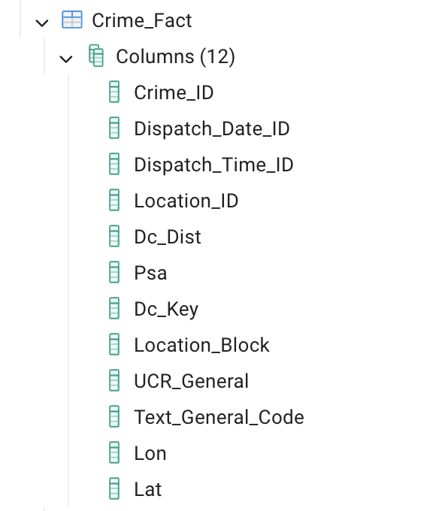

Why there are Lon and Lat which weren't in design: Because the query for finding correspondent Lon and Lat is kind of slow, we find and load, attach them after the Crime_Fact table for later operation.

**Delta data for business dim**

This SCD Type 2 is designed for tracking full historical changes in business dimension. Each change to attributes like Location, Name, or Category creates a new row with Effective_Start_Date and Effective_End_Date to record its validity. The Is_Current flag helps identify the active record. This approach ensures complete historical tracking which benefits for reporting trends or analyzing past and present business states. It’s ideal for business dimensions that have frequent change and full history is critical for analysis.

Our delta data for business dim comes fromthe **yelp_business_delta.json** file:

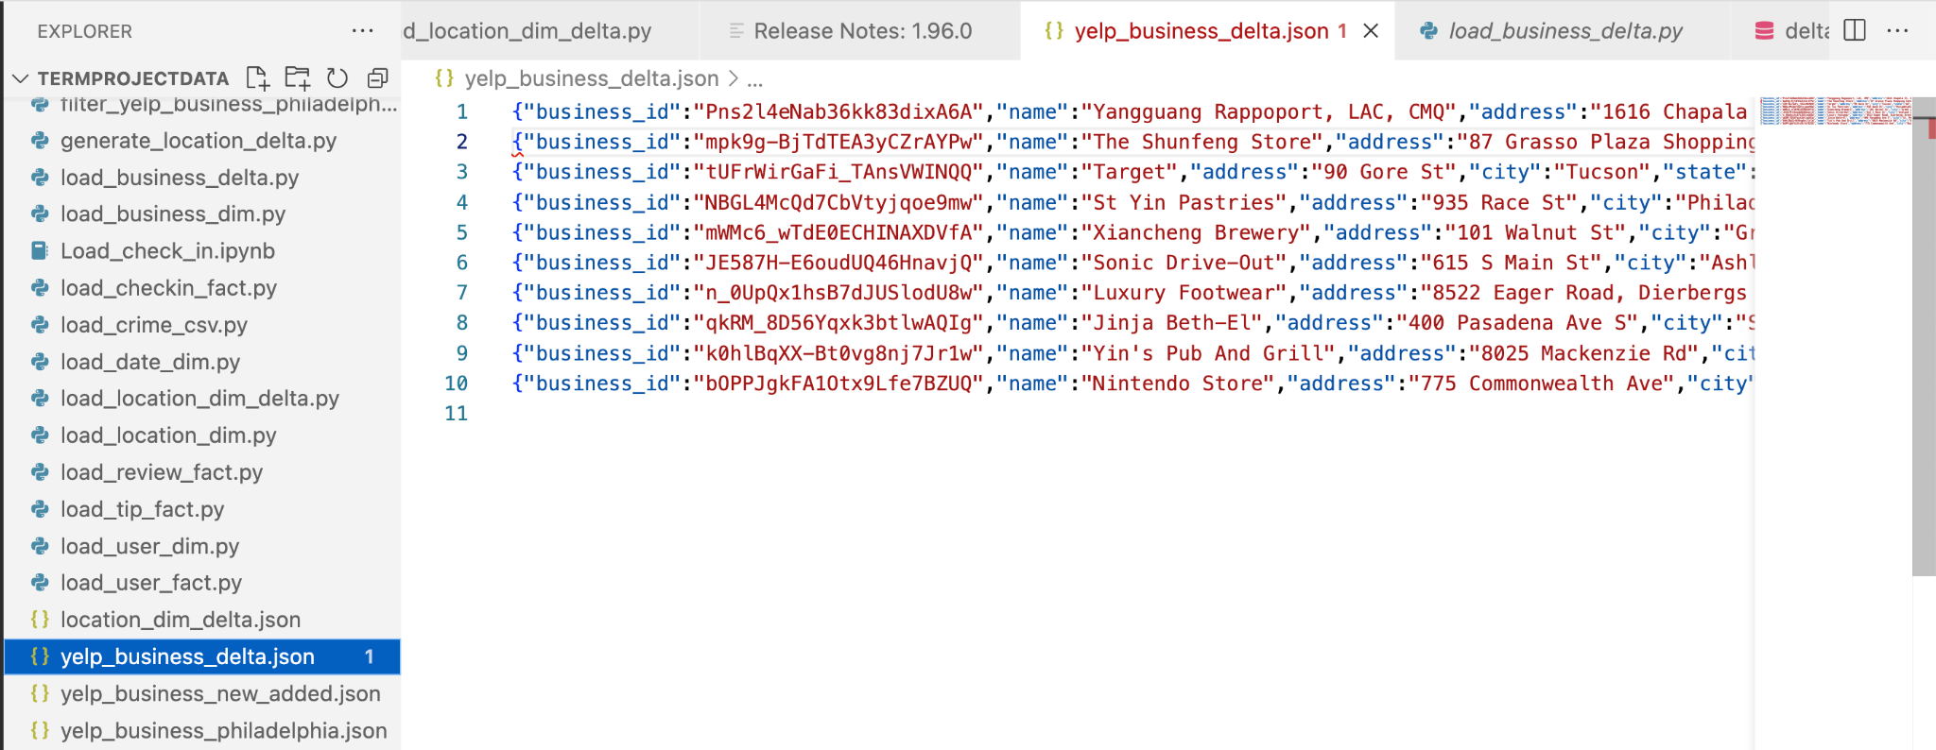

We load the data into the PostgreSQL database.

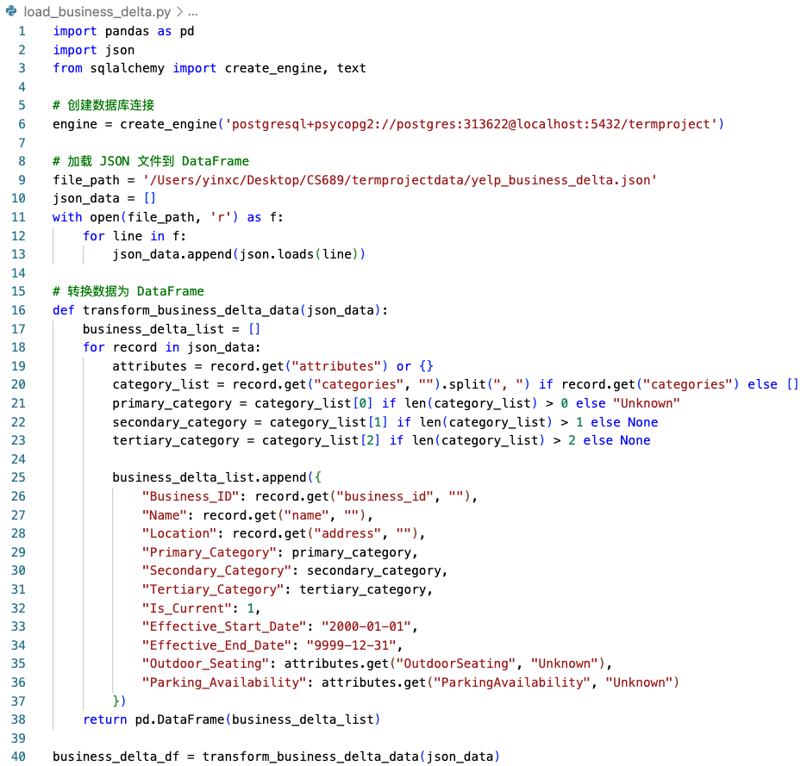

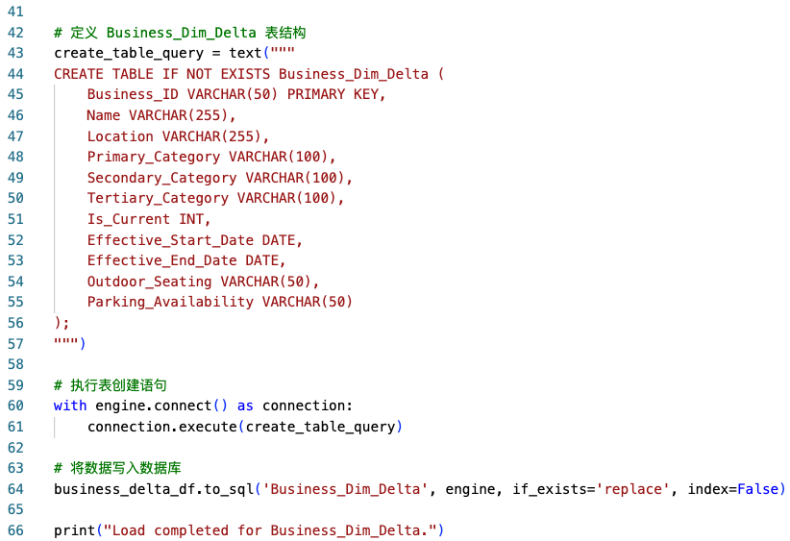

We load the data to a PostgreSQL database.

Then we load the data with DBMS code query:

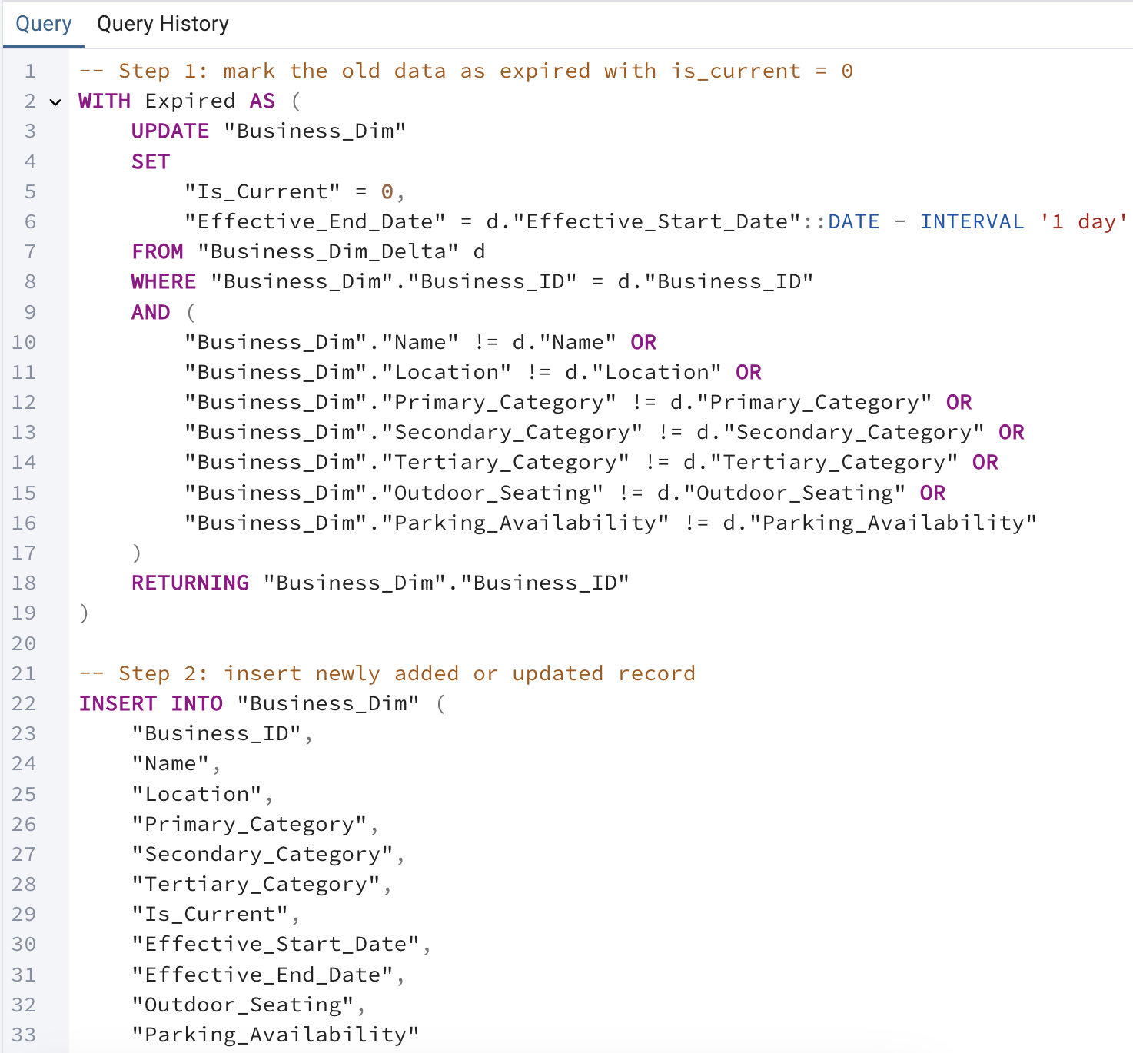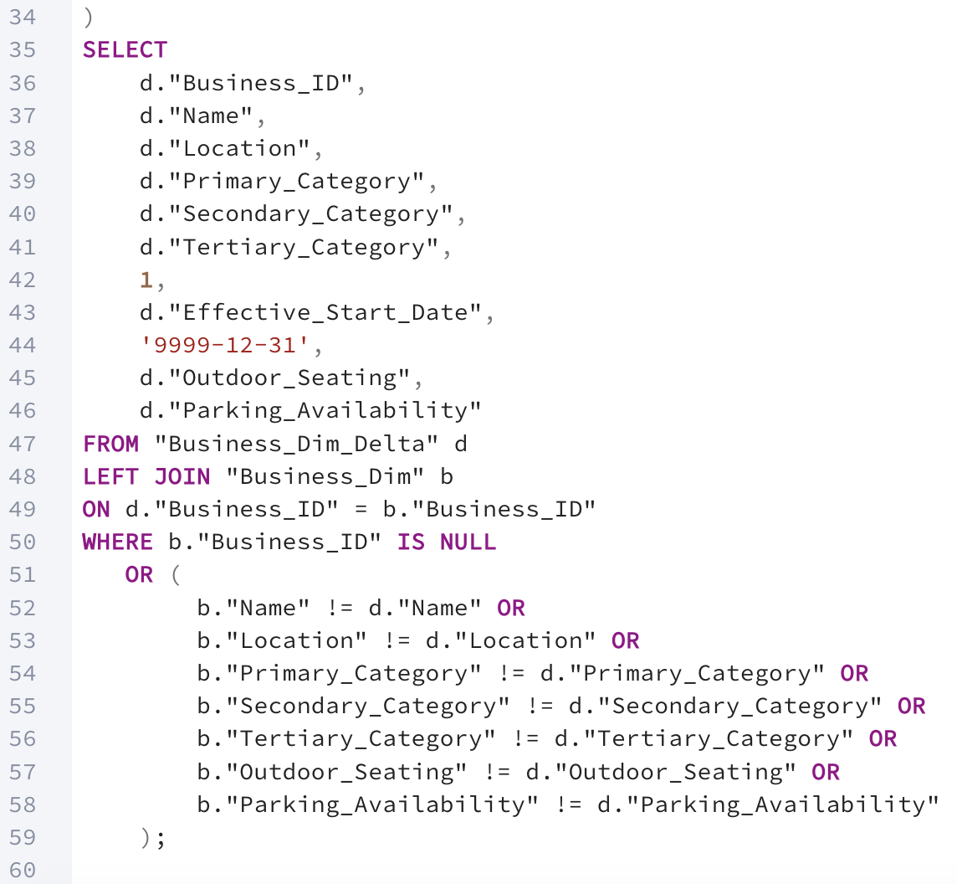

Executed:

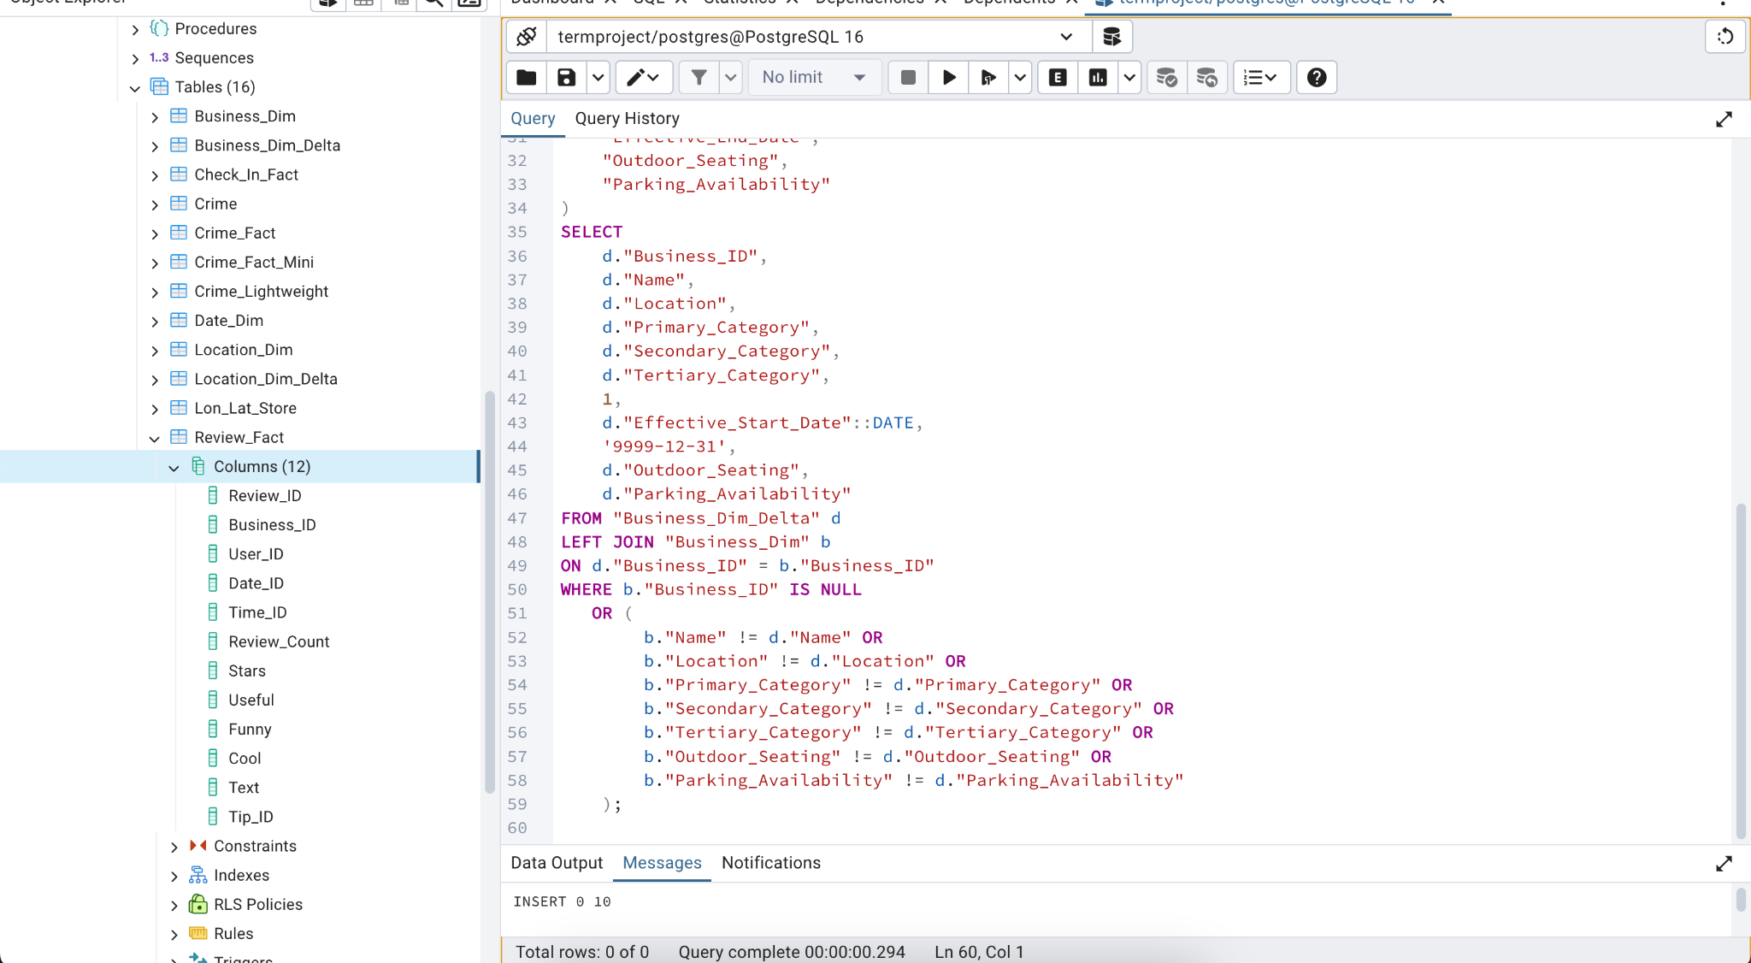

Checking Inserted Data for Business_Dim:

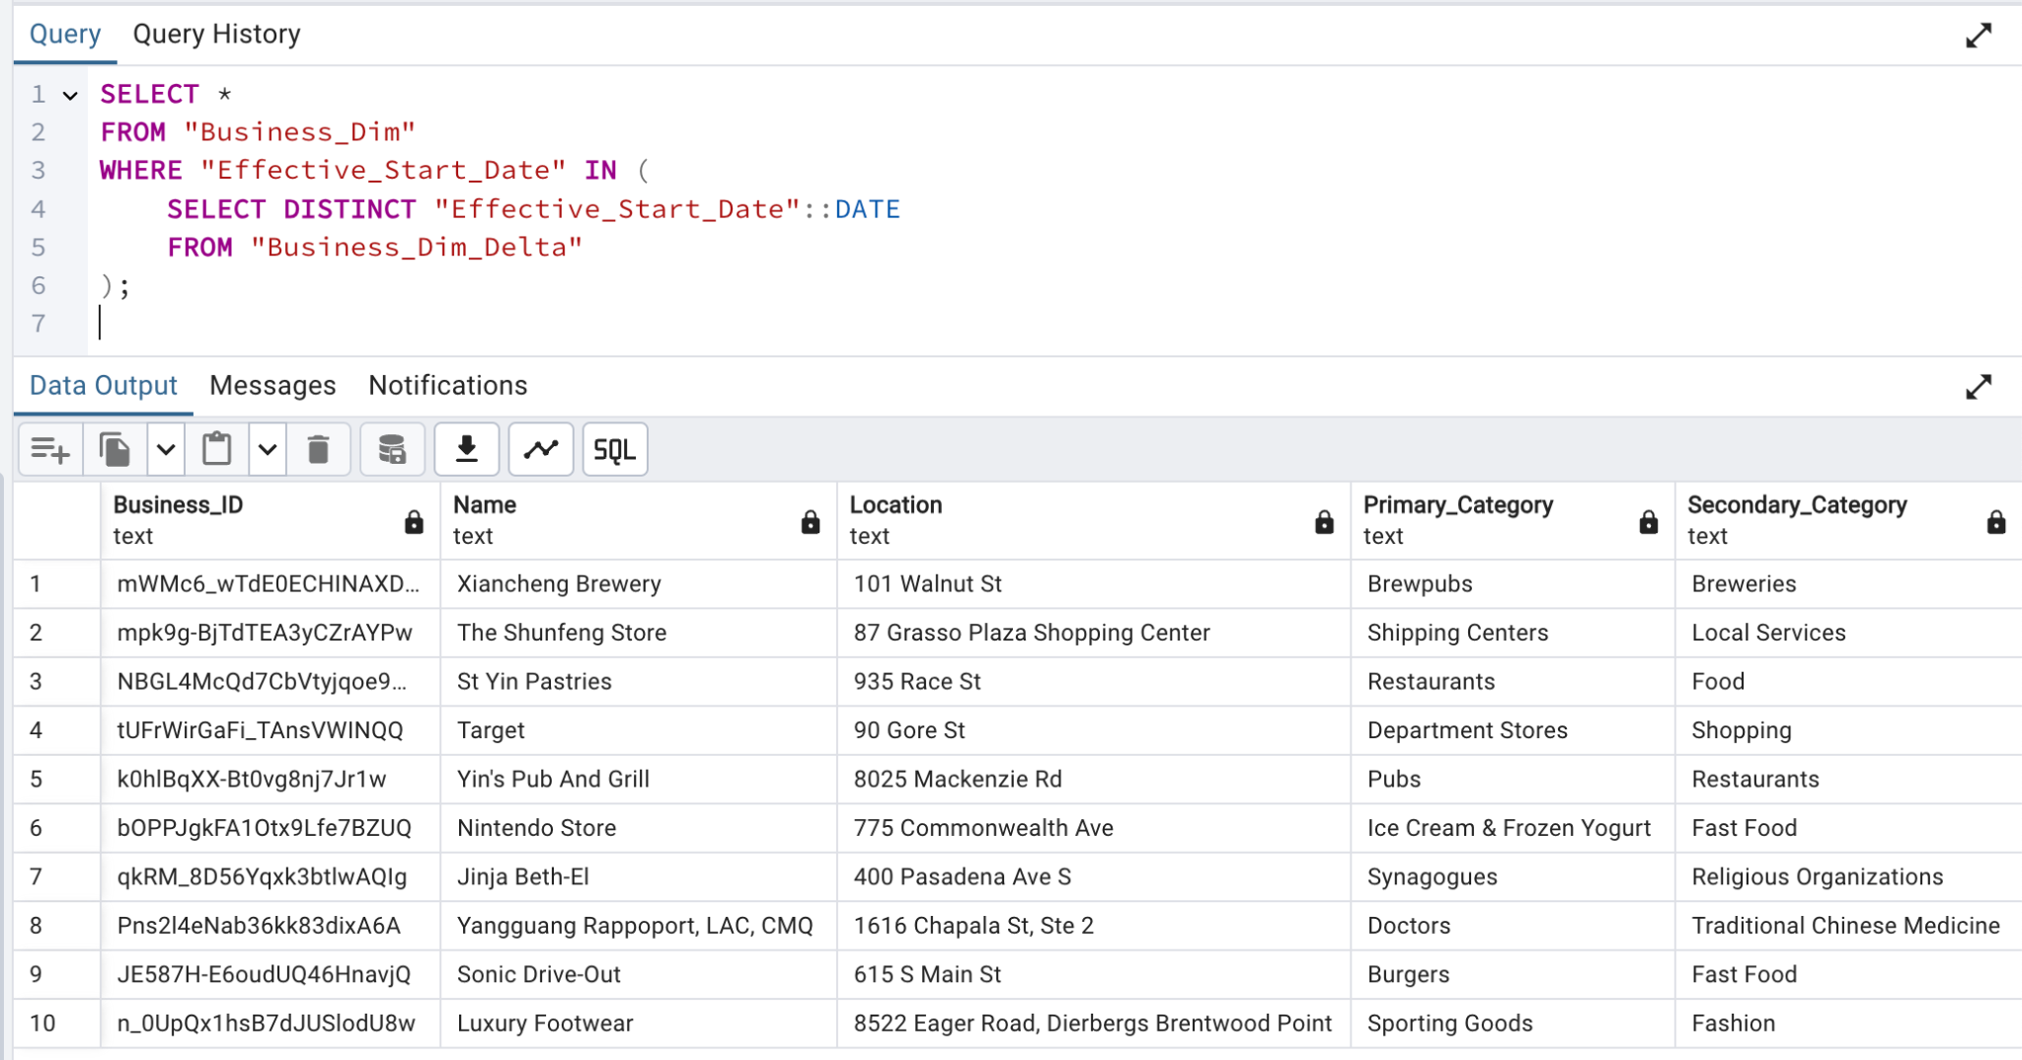

**Delta data for location_dim**

This SCD Type 3 design is designed for tracking limited history (current and previous City, State) without adding the complexity of multiple rows like SCD Type 2. It uses columns like Previous_City, Start_Date, and Current_Flag to track changes efficiently. It’s suitable for dimensions like location with low change frequency and when reporting on the most recent changes is sufficient.

Our delta data for business dim comes fromthe **location_dim_delta.json** file:



load data to PostgreSQL:

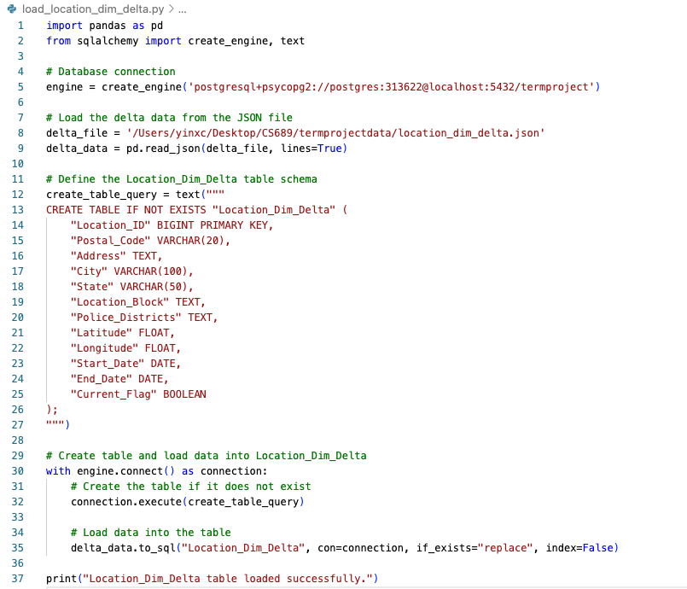

Data is loaded to postgreSQL:

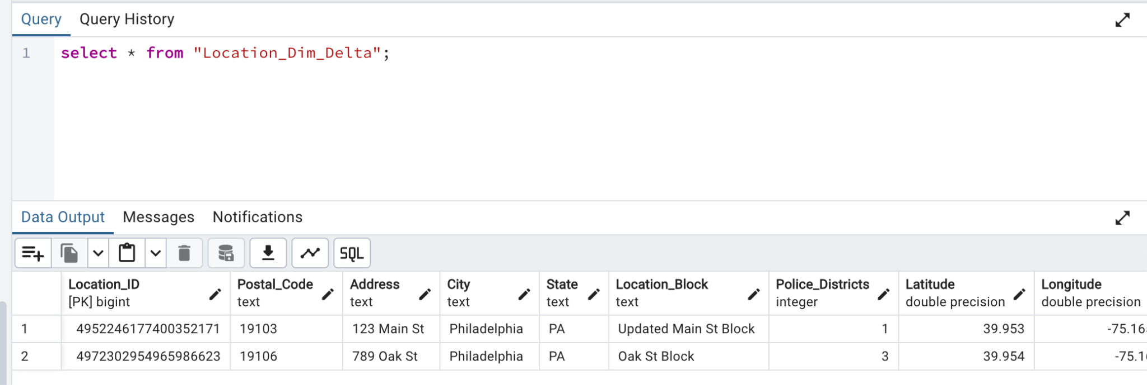

Add the required columns to Location_Dim

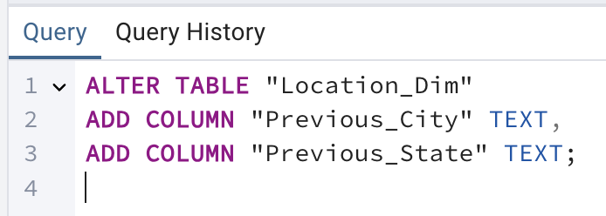

Load data from Business_Dim_Delta to Business_Dim, check if data already exists, or if data is updated, or if data is new data.

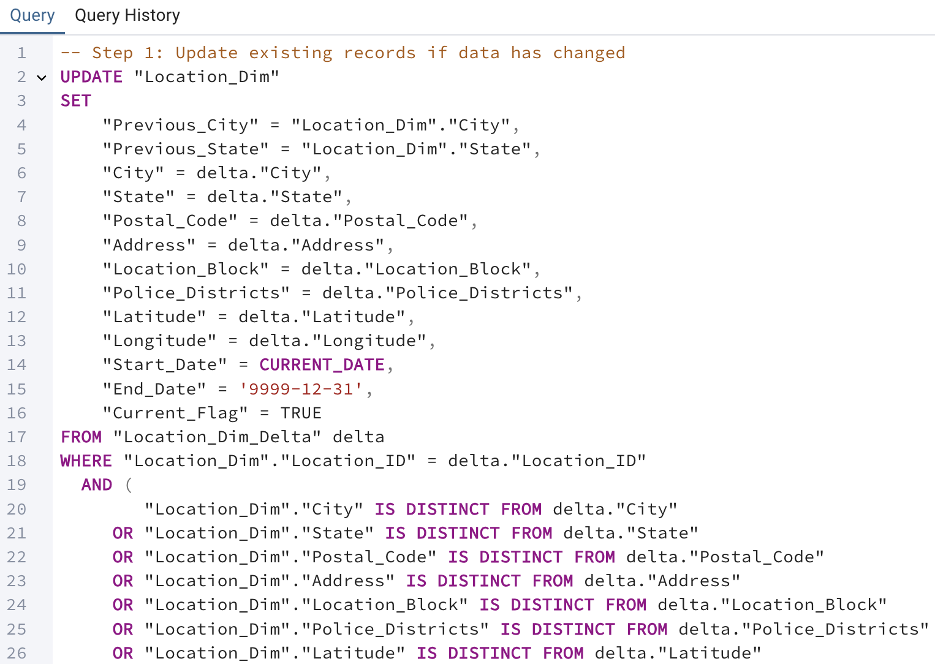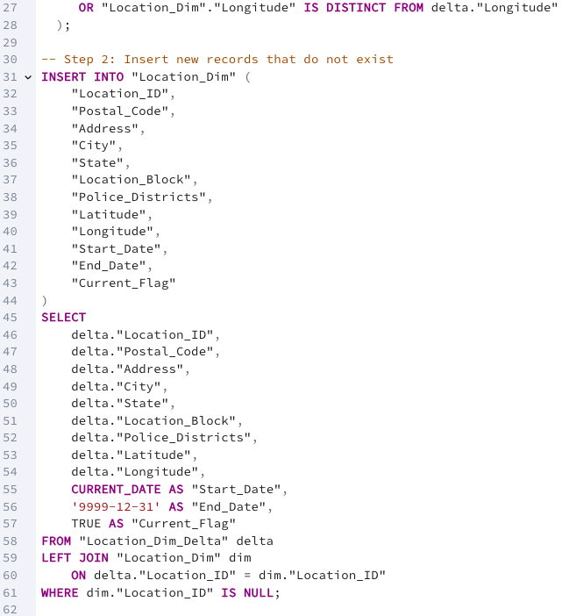

Data have been loaded successfully:

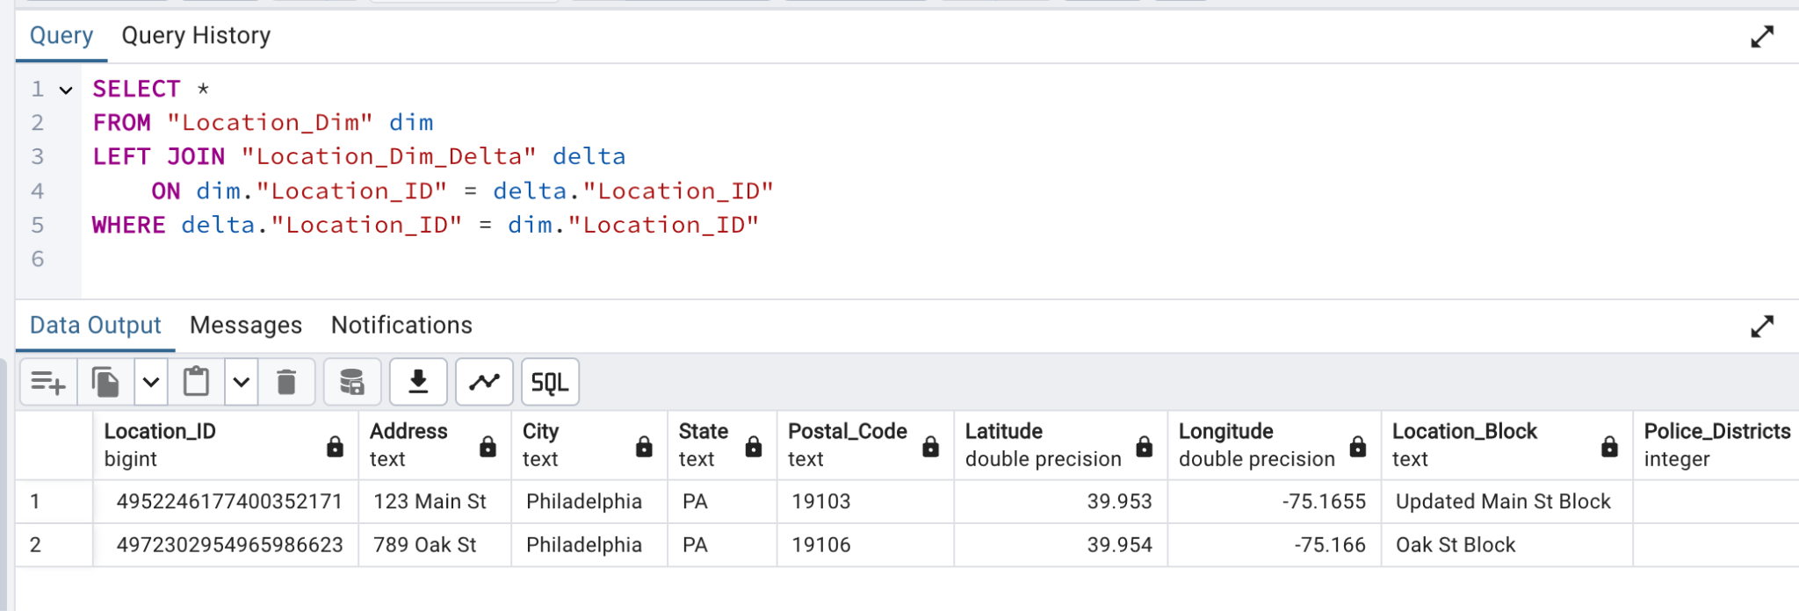

# **Visualization and Analytics**

**How does the time of day, day of week and cuisine type, impact customer check-ins ?**

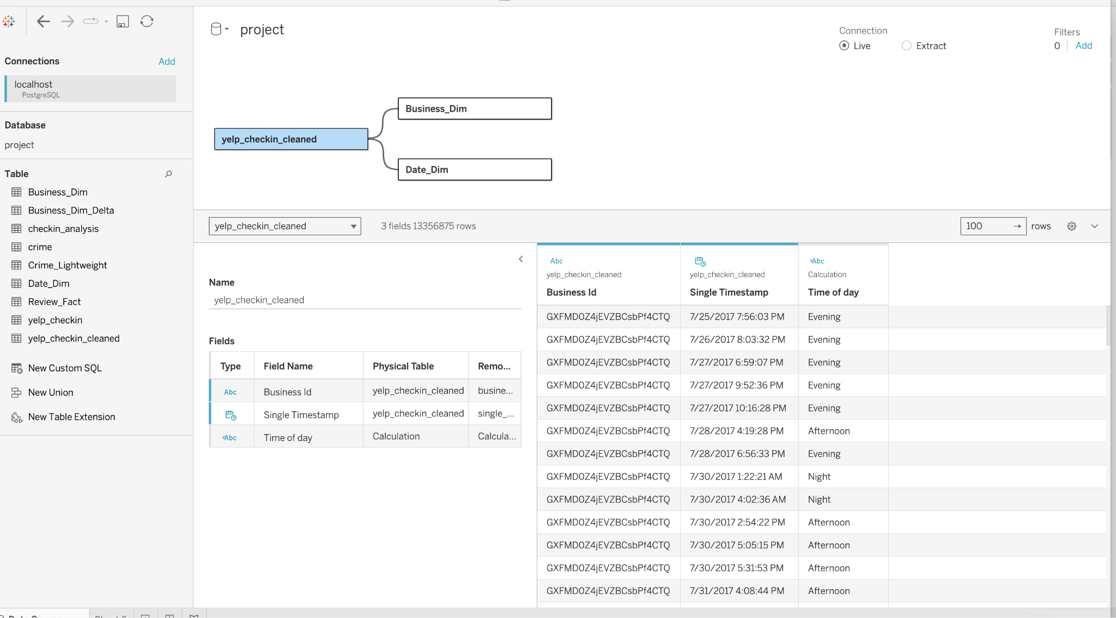

* + Add calculated fields

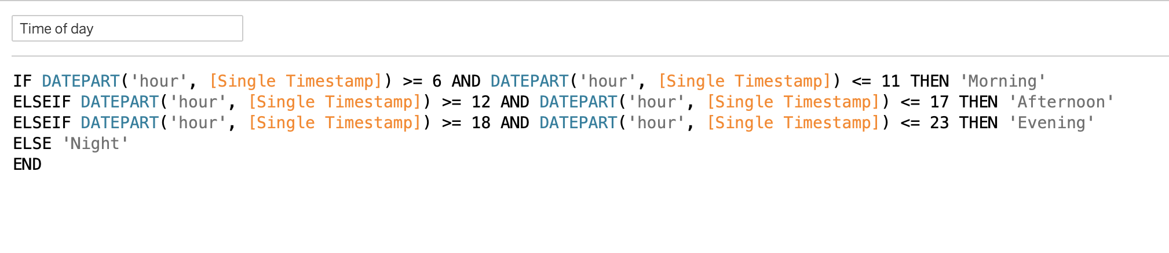

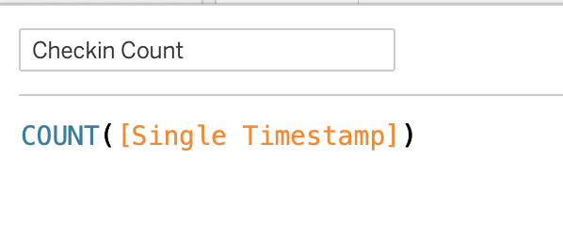

* + Add filters

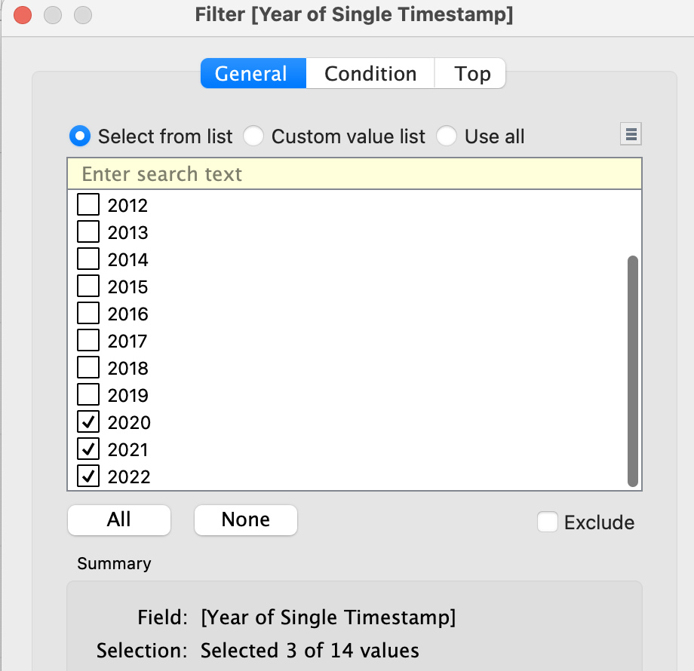

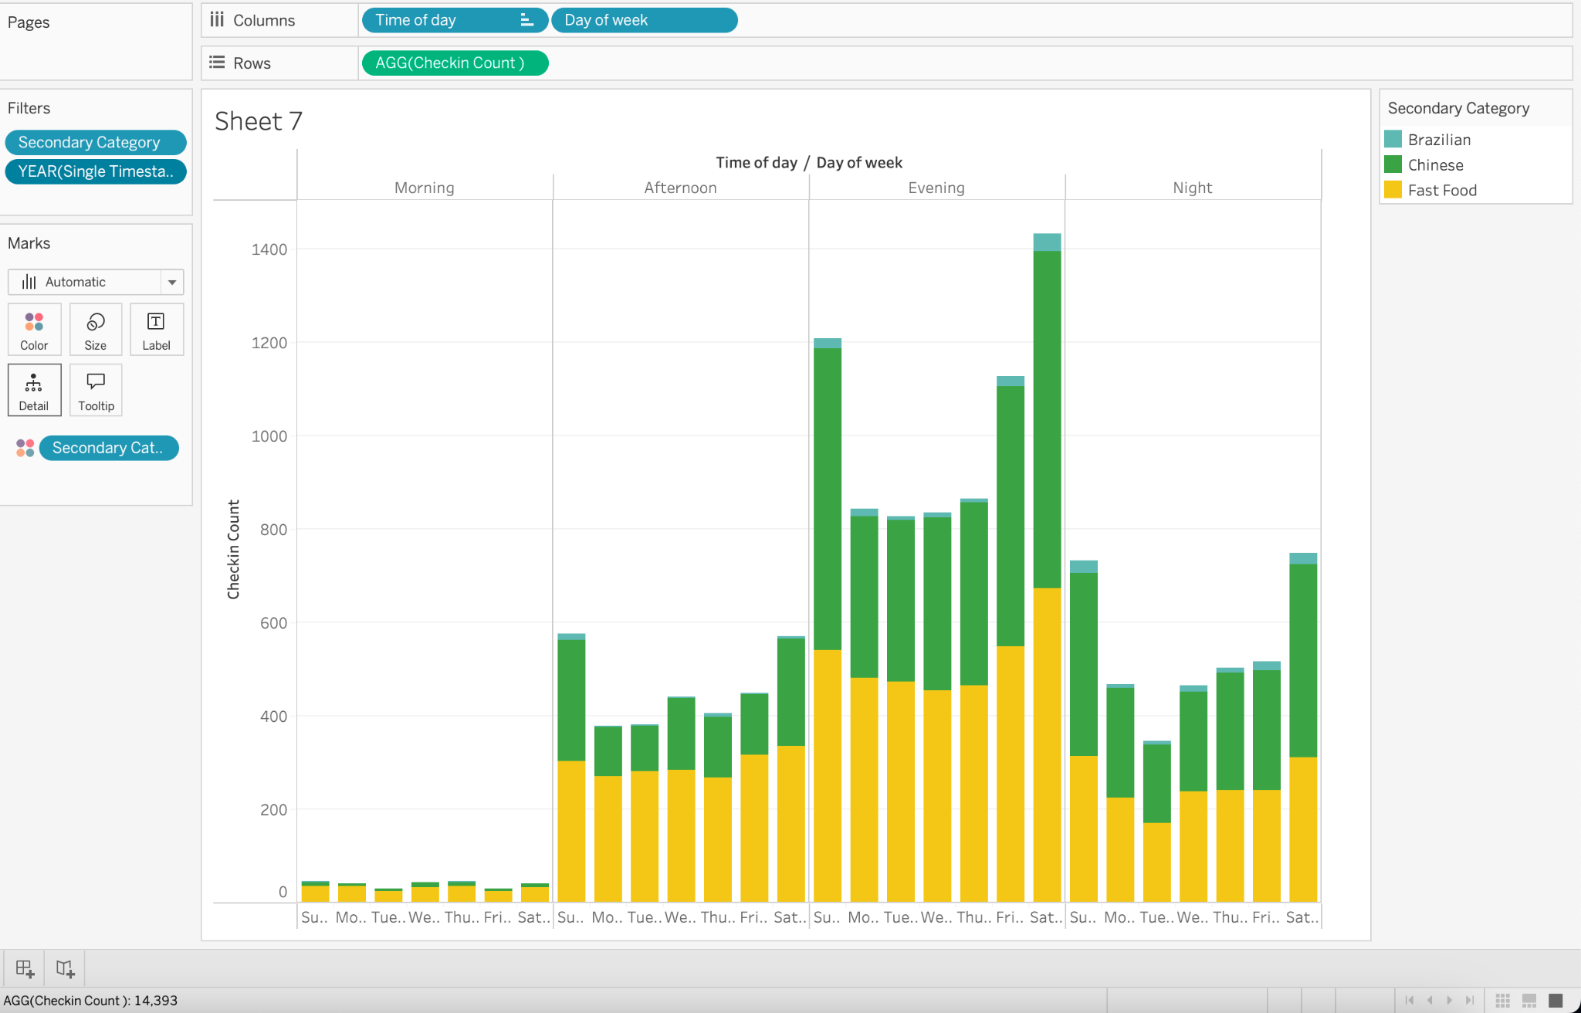

Our stacked bar chart analyzes the impact of time of day, day of week, and cuisine type on customer check-ins, filtered for **2020-2022**, by:

* **Facilitating Comparison**: Displays overall check-ins while highlighting the contributions of different cuisines (e.g., Brazilian, Chinese, Fast Food).
* **Revealing Trends Over Time**: Captures patterns by time of day (e.g., peak evenings) and day of week (e.g., busy weekends).
* **Exploring Multiple Dimensions**: Provides insights into the interplay of time, day, and cuisine type with drill-down/roll-up functionality for detailed analysis.
* **Ensuring Visual Clarity**: Clearly separates total check-ins and categorical breakdowns for easy interpretation.
* **Balancing Simplicity and Insight**: Combines a view of broad trends (e.g., evening spikes) with detailed contributions for each cuisine.

**Which cuisine types have the highest check-ins during different times of the day?**

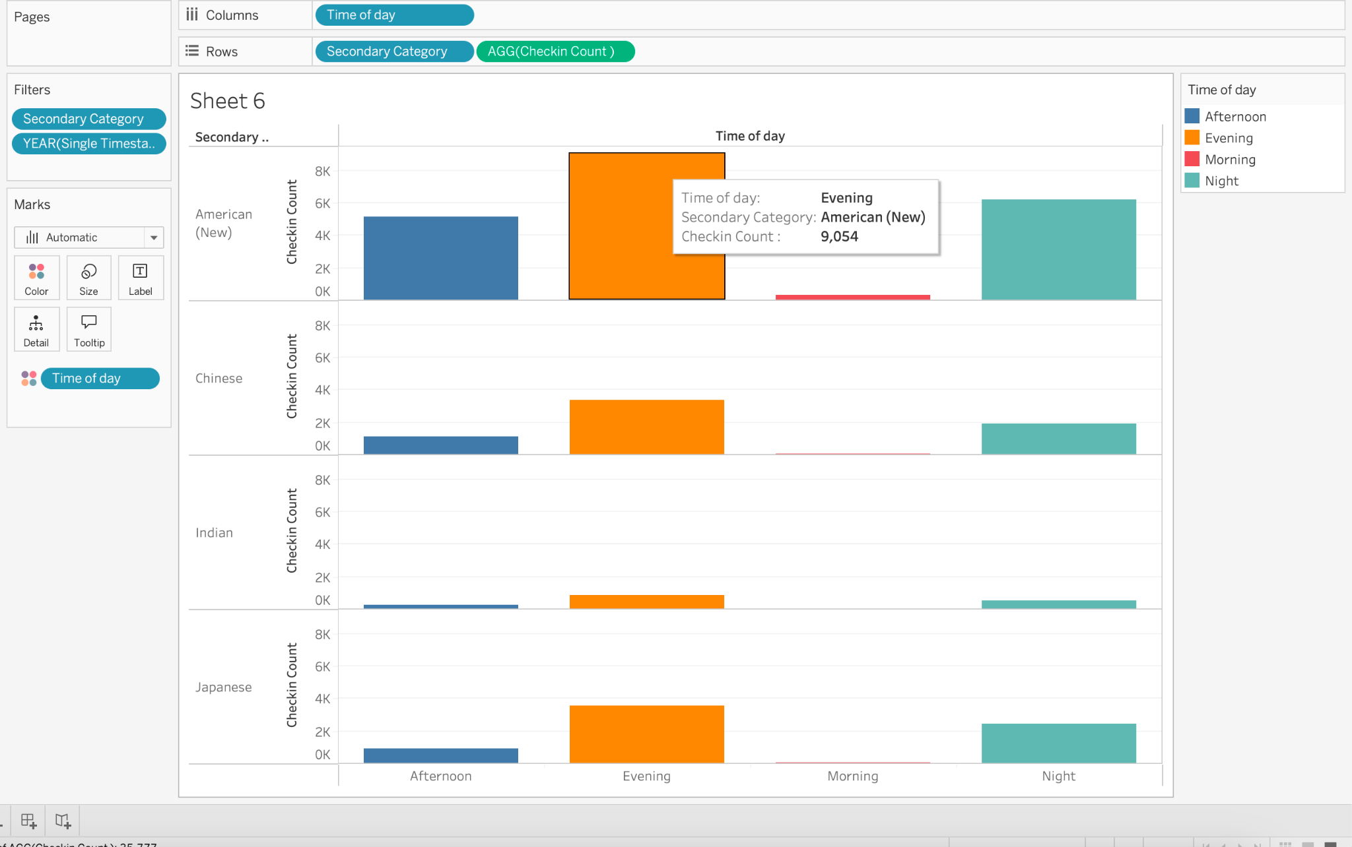

Our bar chart analyzes time of day, cuisine type, and check-in count while incorporating a **year filter** (2020-2022) by:

* **Facilitating Comparison**: Clearly compares check-in trends across cuisines (e.g., American, Chinese) and times of day.
* **Highlighting Temporal Patterns**: Shows peak times for check-ins, such as evenings for American cuisine.
* **Segmenting by Category**: Separates cuisines into rows for focused insights without clutter.
* **Displaying Proportions**: Uses colored bars to illustrate the distribution of check-ins across time periods for each cuisine.
* **Providing Clarity**: Ensures an intuitive layout filtered by years for easy interpretation.

This visualization is simple, clear, and well-suited for analyzing customer behavior across time and cuisines.

**What is the impact of crime on business if there is(Philadelphia Crime Data) ?**

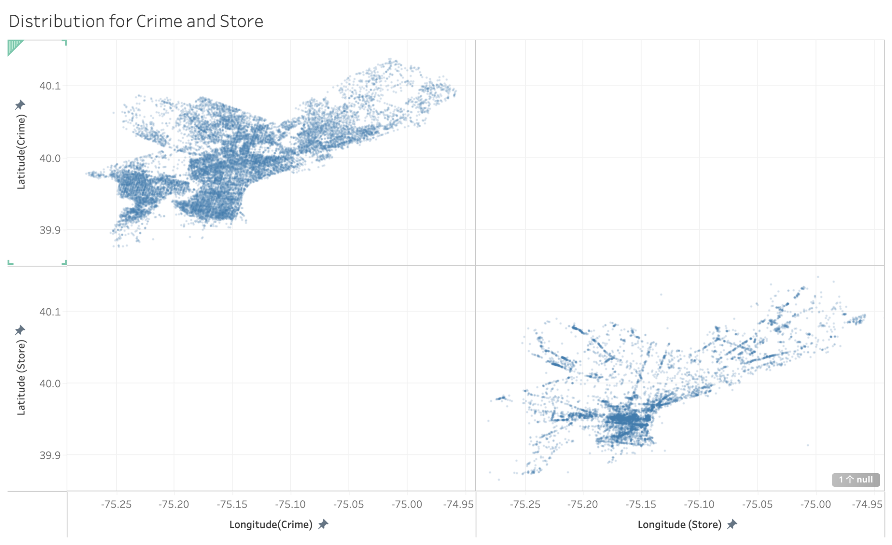

A scatter plot of crime and store distributions—was chosen because it effectively shows the spatial relationship between crime locations and store locations.

From distribution of business and crime incidents we can see that businesses in high-crime areas tend to have lower customer check-ins, negative reviews, or reduced performance metrics due to safety concerns. This analysis suggests that public safety directly influences business success and customer behavior, emphasizing the need for targeted interventions to improve safety and support businesses in affected areas.

**What is the relationship between number of reviews, reaction to review and number of tips?**

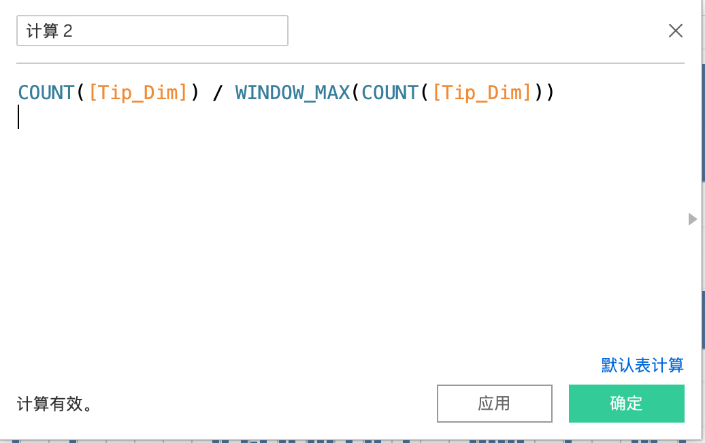

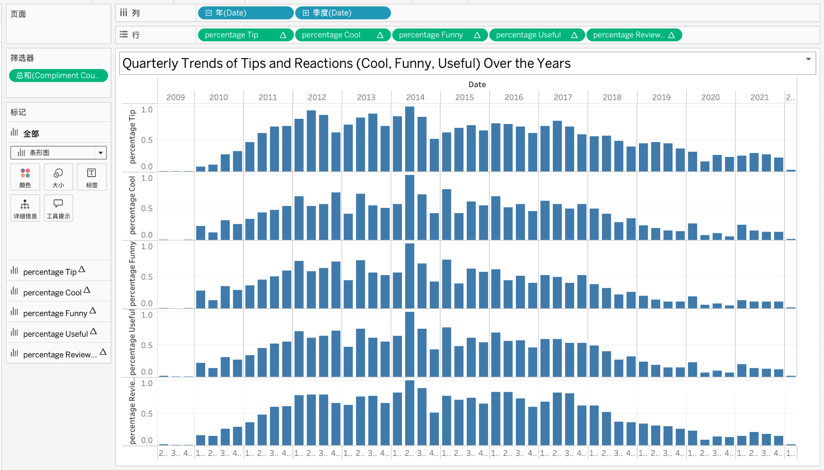

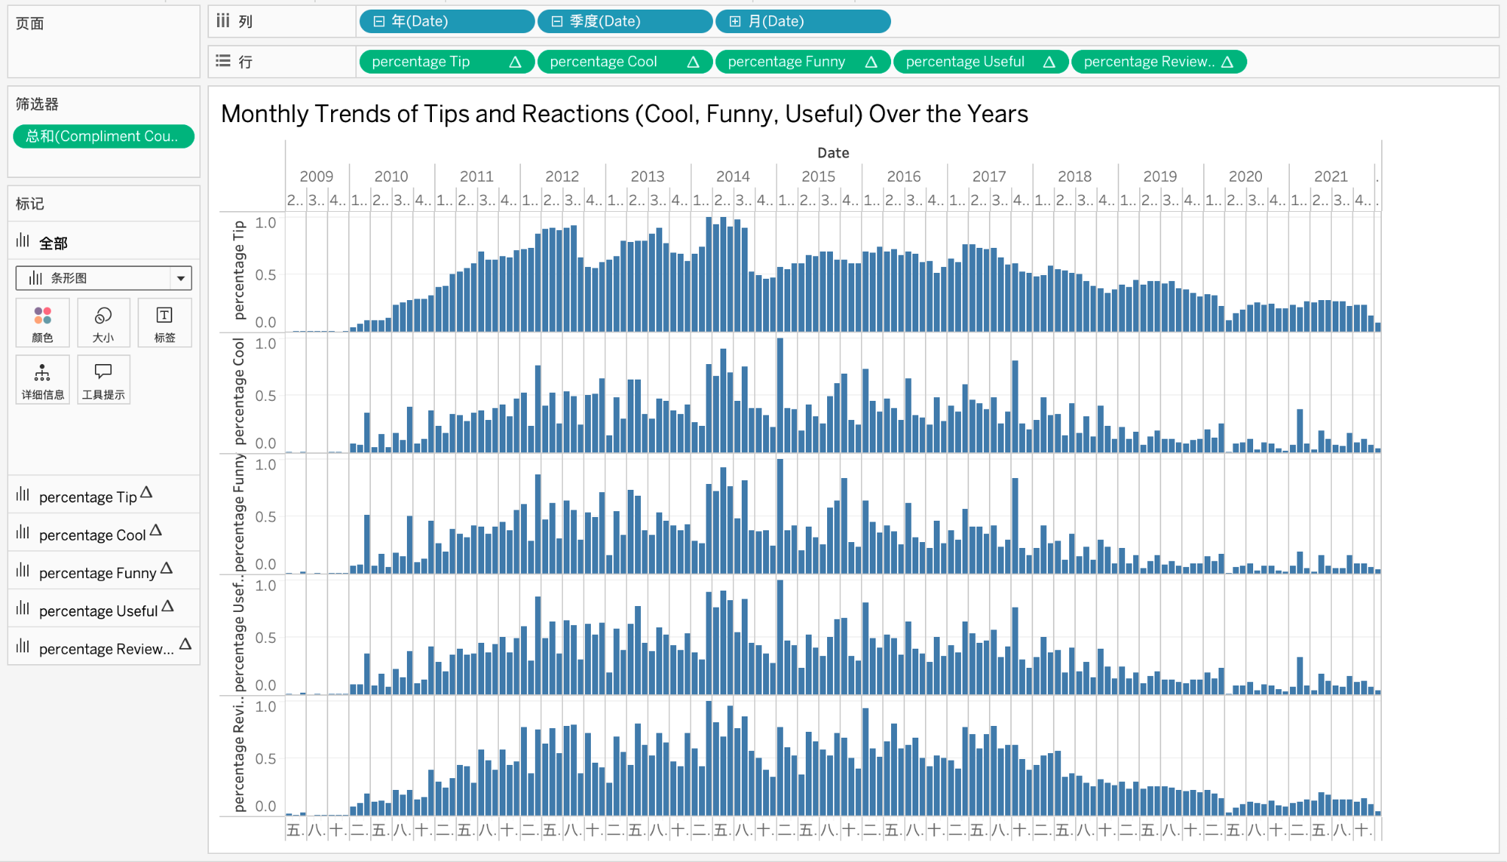

Activity varies across quarters, with Quarter2 and Quarter3 generally showing higher engagement than Quarter1 or Quarter4. This indicates seasonal factors, such as holidays or events, may influence user participation. Also, there are occasional spikes in "Funny" or "Cool" reactions that deviate from the general trends. These could indicate specific campaigns or changes in user interaction behavior. Last but not least, the relative proportions of reactions remain consistent across years, suggesting stable user behavior in how they interact with tips.